How to check the fps of the video

​1. For the fps of the video, you can config it on the MDVR's settings.

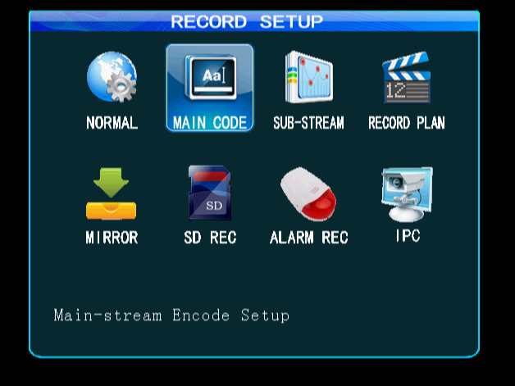

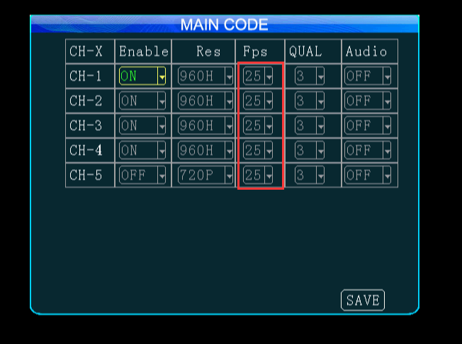

2. However if you don't know the information or can not access to the settings of the MDVR, you can use the follow ways.

