RJ45 definition

For our MDVR, it have a RJ45 port, many customer want to know the RJ45 definition, then he can use it to connect the IPC or do others. For this, 4/5 pin is +, 7/8 pin is -.

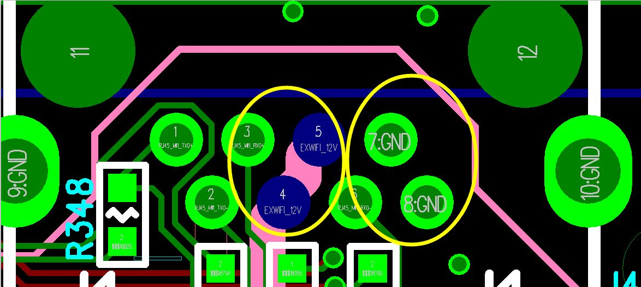

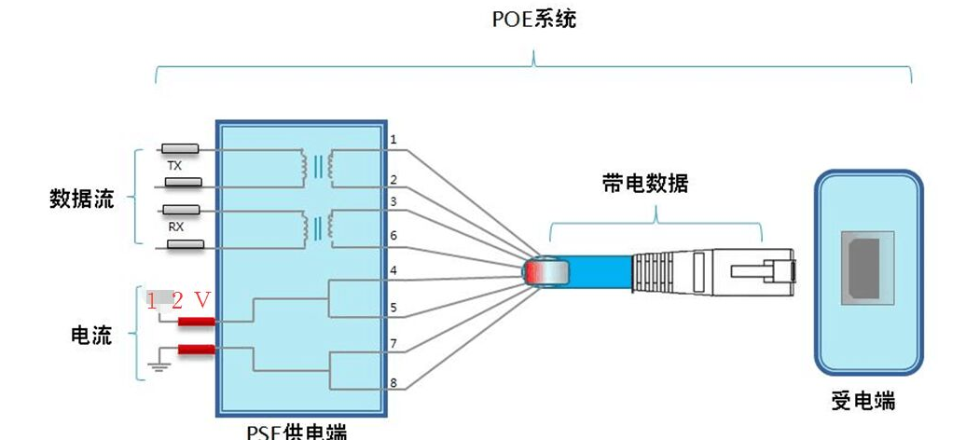

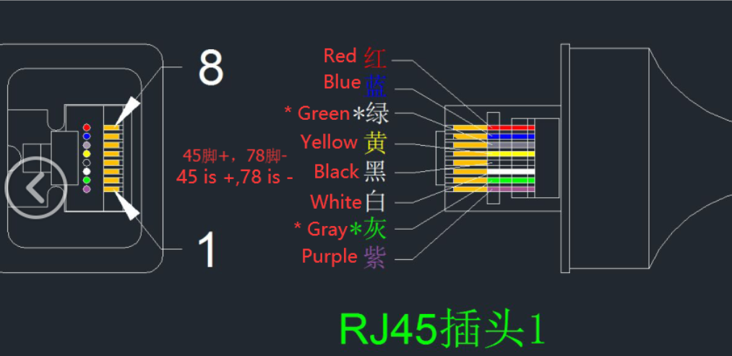

For JH8-HYBRID(V2) and JH8-NVR, it also had another air network port, it can converted to RJ45.




