Setting CBR in NVR is Invalid

​We did two experiments to test CBR IPC with and without IR function. 30 minutes each video.

Without IR function
Day: 237MB, Night: 192MB.

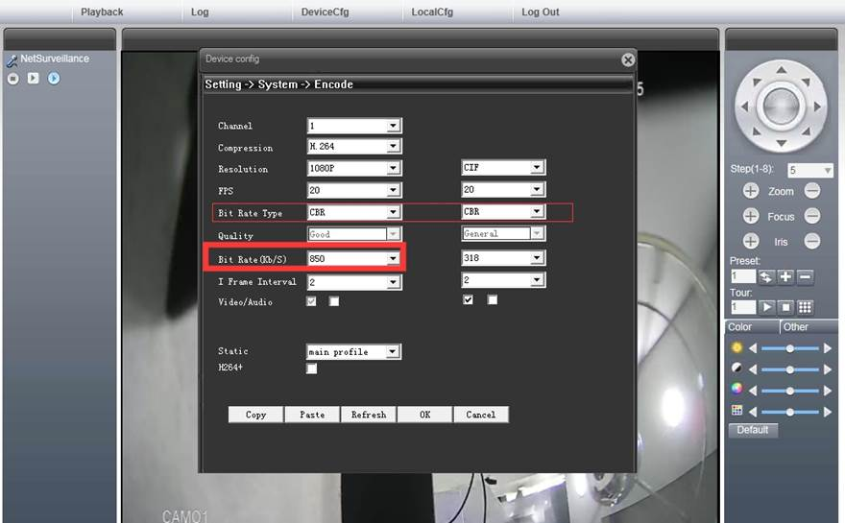

With IR function, Day: 232MB. Night: 292MB.

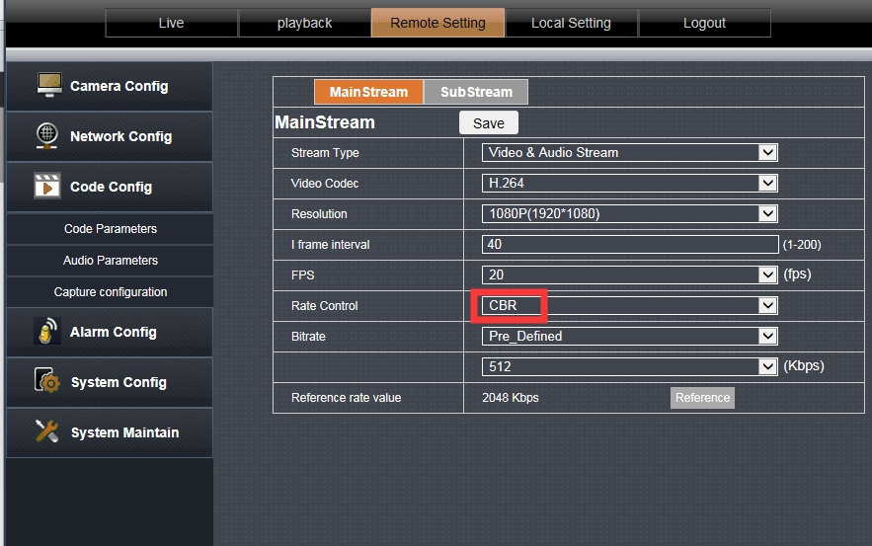

Results:
1: the file size differences are made by IP camera not Mobile-DVR/NVR

2: the reason why in CBR mode, there is still files differences during day and night is that the bit rate control of the IP Camera has not been done accurately enough, this result is within the normal fluctuation range.

The only way to limit the file with the same size is to fixed code rate by IPC.

