How to connect the IO cable to the Door Sensor

​1. Generally, the Door Sensor(Door Magnet) is used to control the status of the door, open and close.
This one is door magnet, you can find it in the market. Normally, the door manget has two parts, one part is connect to the cable, one cable is 12V and another cable is GND.

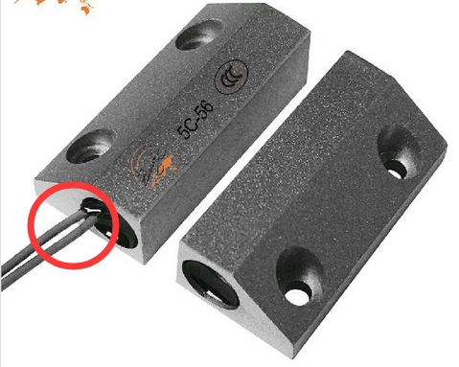

2. The following picture is just for one door, so if bus need two doors, you need connect another door magnet to connect sensor2 and 12V, but please notice that both sensor1 and sensor2 need connect to the door magnet, so please consider this, before this, you can test in your office using the door magnet.
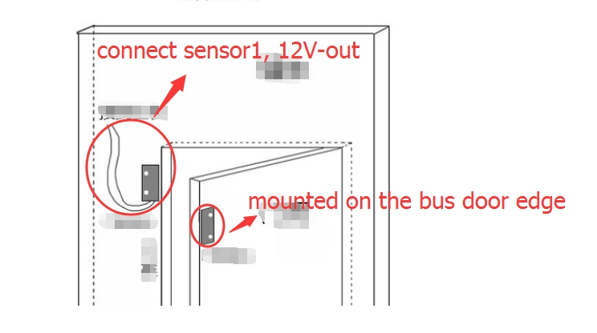
Action description
1. When no magnetic object is approaching, the sensor is off.
2. When a magnetic object approaches the sensor, the sensor moves on when it is away from the edge of the sensor.
3. When the magnetic object keeps approaching the sensor, the sensor is turned on until the magnetic object leaves the sensing distance greater than the time and disconnects.
Precautions
1. Do not install the sensor on magnetically permeable objects. Prevent the sensor from working or responding slowly.
2. The sensor body must not collide and fall from high altitude.

