# How to fix the device without GPS position with Web Client

​The problem occured like following:

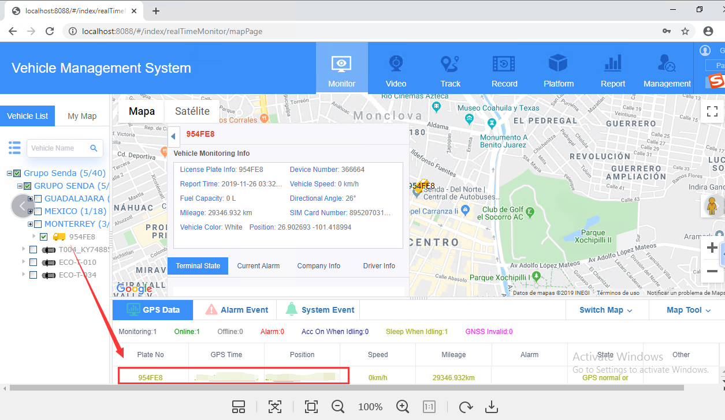

1. Check the Websocket server port, use cmd command to check the port is opened or not. The port is 6617.

netstat -ano|findstr 6617

telnet 170.231.229.82 6617

2. Telnet the port, and found that your IVMS Server didn’t make port mapping for this port, so first is to map it. Now it’s working because I change the port of 170.231.229.82 to 127.0.0.1, so it works for the position. When you finish the port mapping, you need change the parameters of the GPSDataSvr.ini file. Change the Ip from 127.0.0.1 to 170.231.229.82. And then save the settings, and go to the IVMS Server Manager and restart the Web API Server.

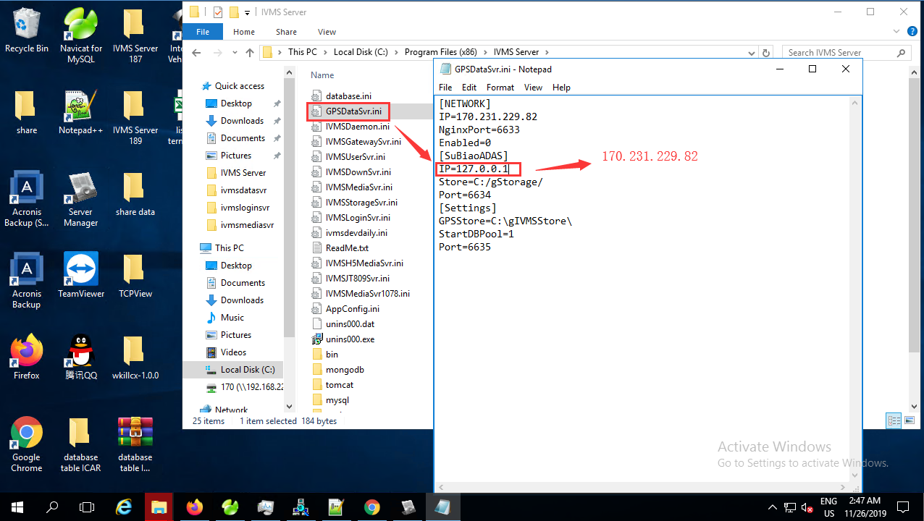

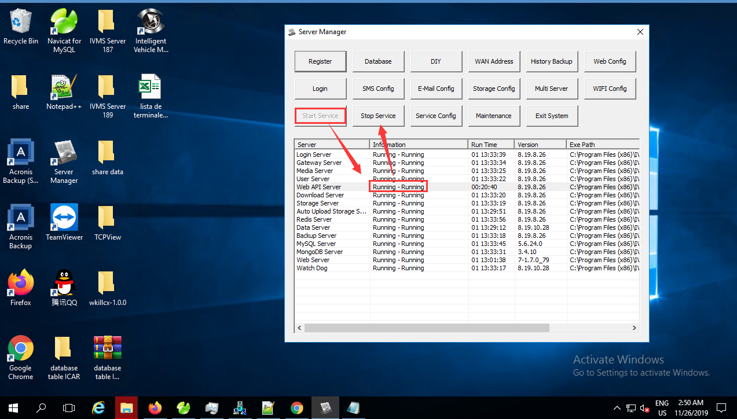

After restart the Web API Server, log out the Web client account and re-login again, it will work.

