​The problem occured like this picture:

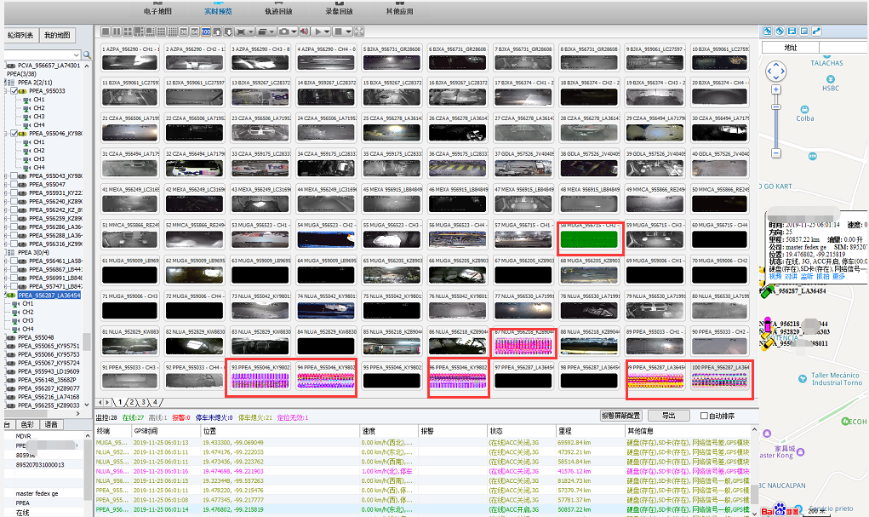

Reason:The reason is because that the IVMS Client use SDL mode, if users login the client and request many channels, such as hundreds of channels, it will make the resourse of the graphics chip high occupied. And if the graphic chip is not high version, such as if use 460

Solution:
We found that if the graphics chip version is too low, this problem will occur. The solution is to cancel the SDL option on the video settings on the IVMS Client. You can cancel the SDL settings and then restart the IVMS Client.

