How to test SSD Heater function

Purpose：

Test the working status of the hard disk heating function

Judgement Standard：

Initial Temp 27°C, Power ON MNVR, Check SSD temp, SSD status，Recording status；
Set temp on -20°C,SSD temp lower then -5°，Check SSD status,Recording status.

1. Power ON

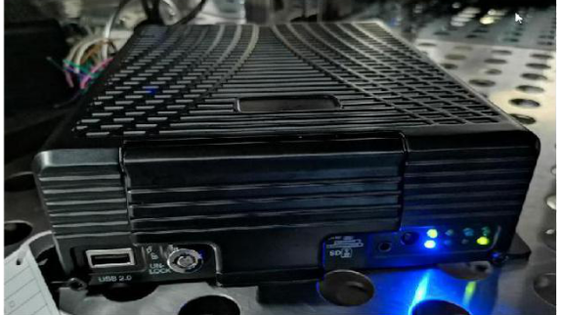

2. POWER: P=U*I, 31.1*0.2=6W

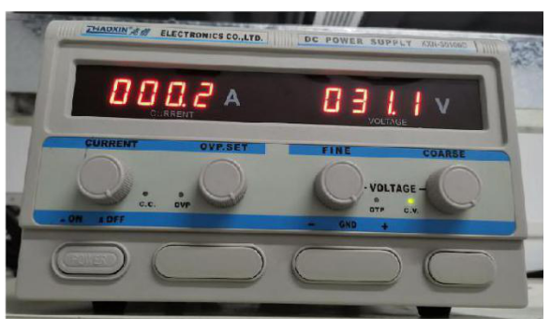

3. Power ON time：2019/11/21-17:33 temp in the box: 23.02℃ SSD Recording Normal

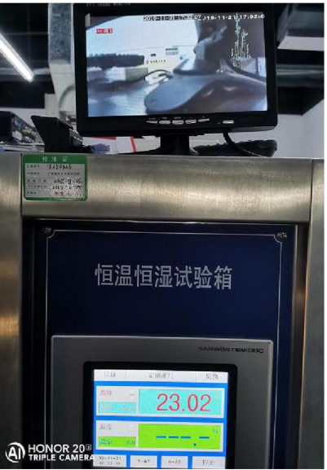

4. Set the temp of the box on -20℃，Temp of SSD on -5℃, Recording normally；

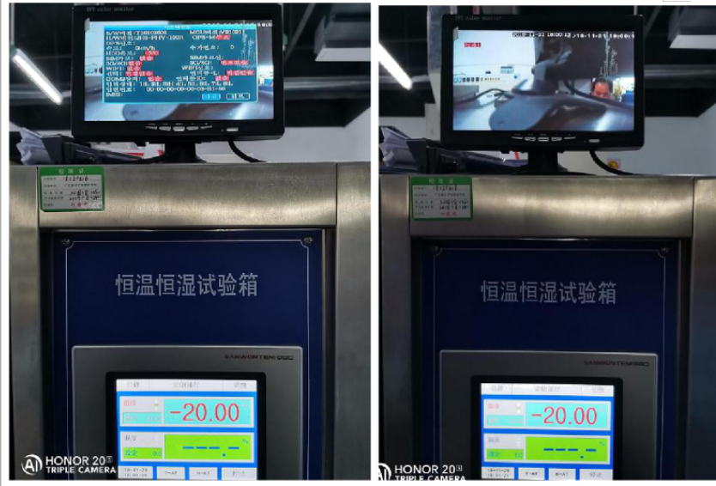

5. Set the temp of the box on -20℃，Temp of SSD on -6℃, Recording normally；

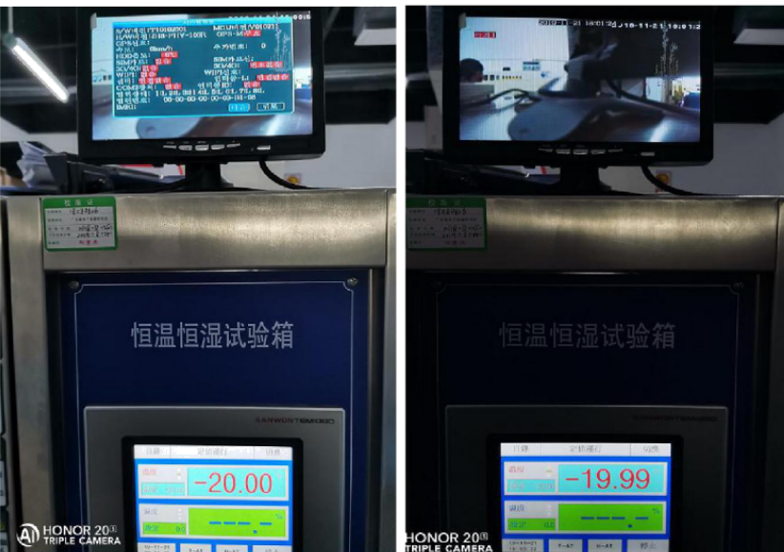

6. Search the videos ，There is no video loss phenomenon when temp of SSD from -6°C TO -5°C , Playing videos also normally.

