How to enable the passenger counter report

There are two ways to enable the passenger counter report.

1. You can login the web side with the admin account.

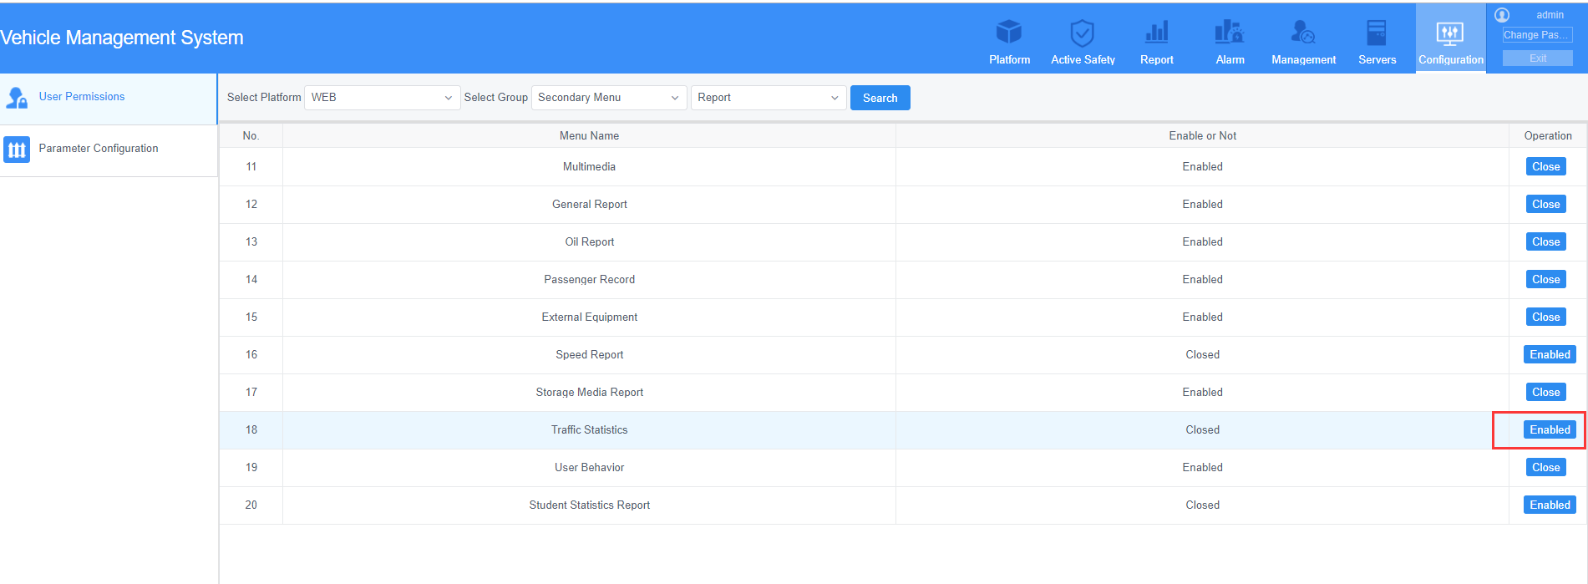

2. You can also login the Database and search the “variable” table. Then enable the passenger counter report.

