How to solve the grec file can not playback in MDVR Player side

​When we want to playbck the grec file, we will found this problem sometimes.

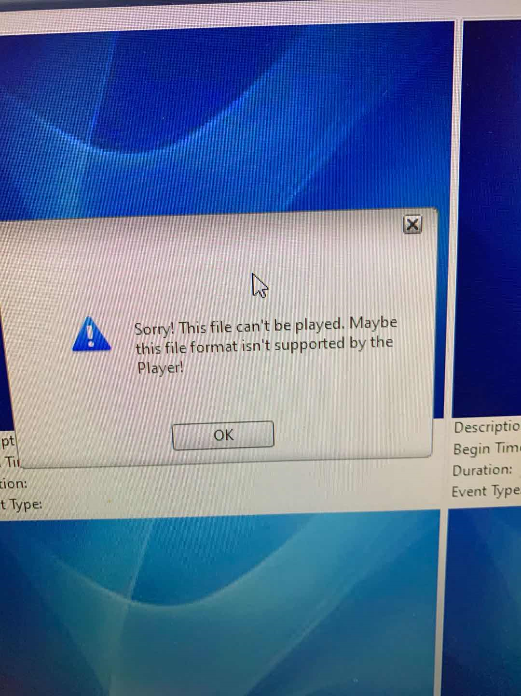

1. First, we need to check if you had changed the grec file name or not, if you change the file name, our MDVR Player will can not find the file, we have specific format inside the file, so you can not change the file name.

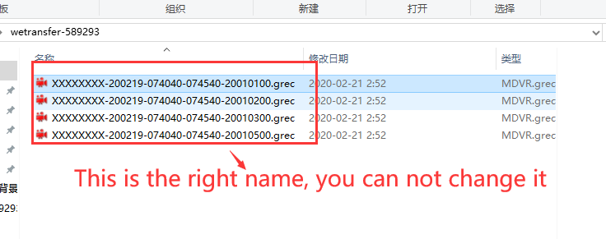

2. Check the MDVR Player side to see if you had chosen this option, after choose this, you need to restart the MDVR Player.

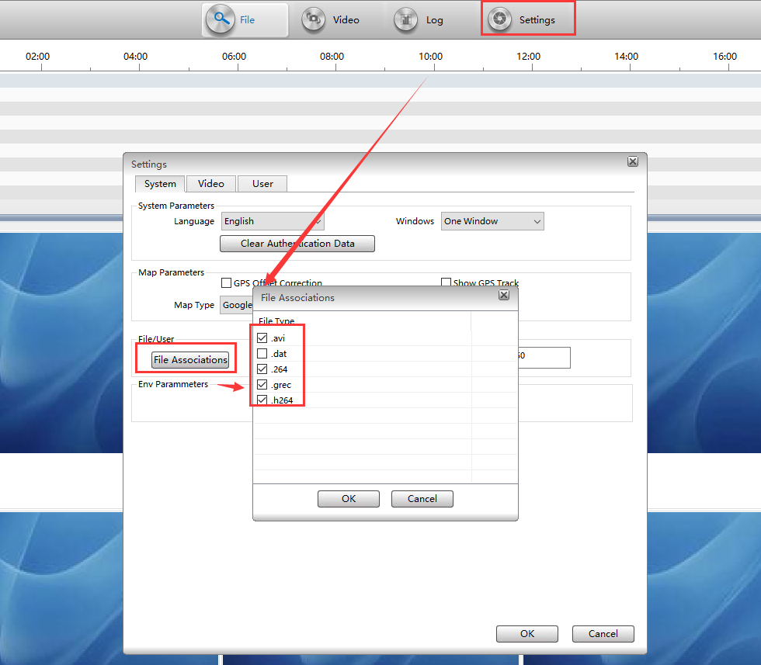

3. Check if the file is encrypted file or not , if it is encrypted file, it will need password to playback.

4. If you had tried all of this, still not working, you can send the file to our technical support engineer, they will ask engineer check it.

