How to update the new version to web side for customer download

1. First, open the IVMS Server installation directory, and find this folder.

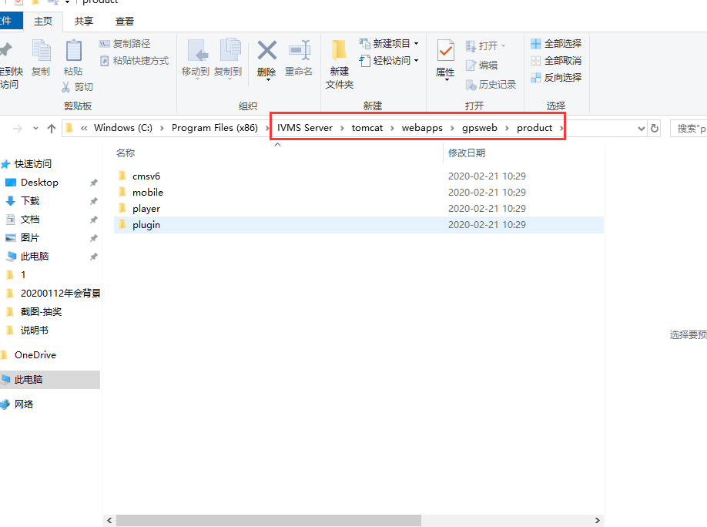

2. If you want to update the IVMS Client version ,you can choose the cmsv6 folder, then replace the new version to this side this.

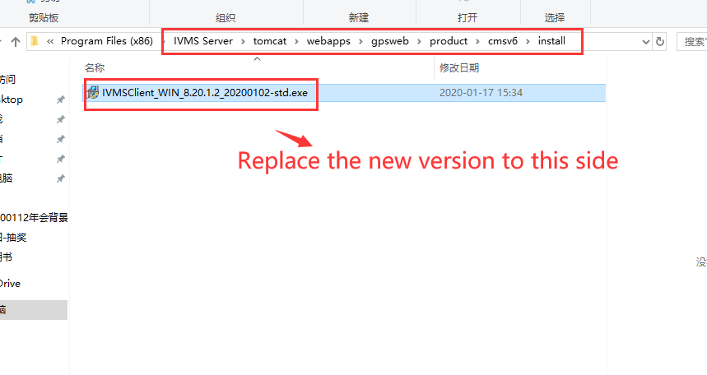

3. If you want to update the MDVR Player version ,you can choose the player folder, then replace the new version to this side like this.

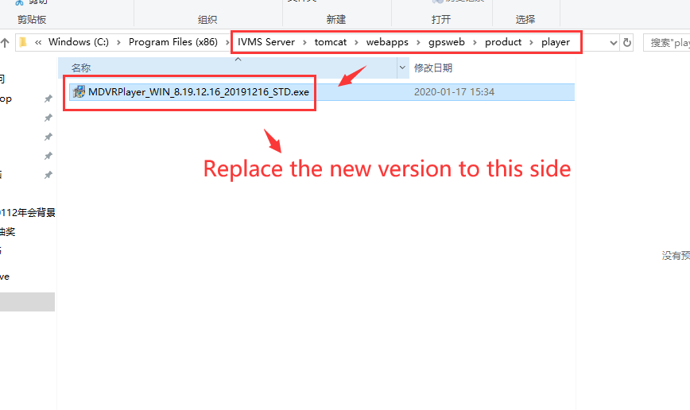

4. If you want to update the Android APK version ,you can choose the mobile folder, then replace the new version to this side like this.

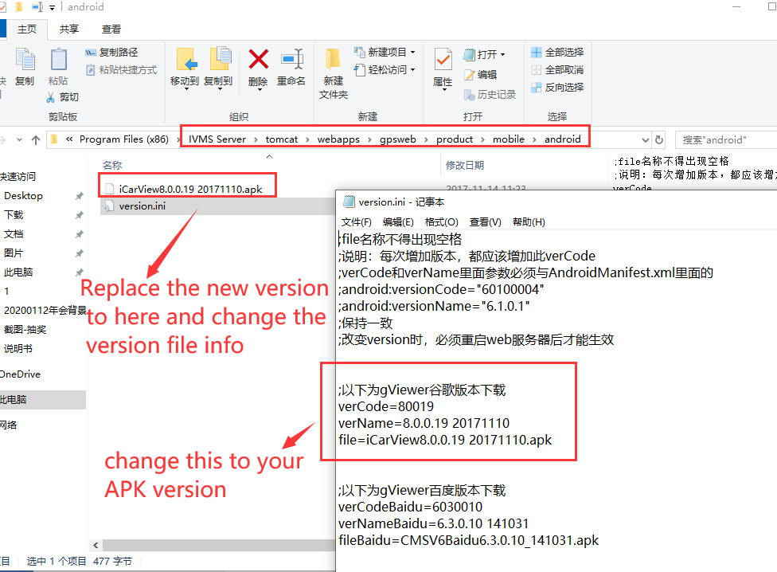

5. After chenge this, restart the server and clear the browser cache, then open the web again, you will see the new version show on this side.

