How to change the icon and GUI image at web side

​1. First, open the IVMS Server installation directory, and find this folder.

2. Find bgimage and logo file,a then change it to what you want, remember keep the name same as the old one, the bgimage and logo are web login page image and logo. You can right click the file and choose properties to check the file details.

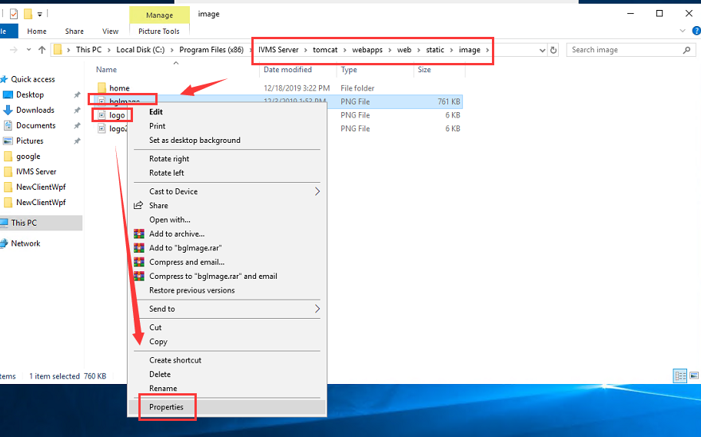

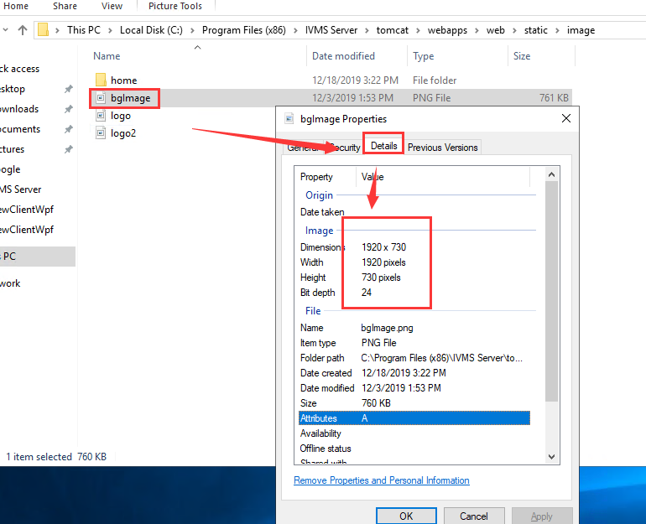

3. After replace these two file, then restart the server and clear the browser cache, you will see the icon and web login page had changed to the one you replaced.

