How to solved the web show undefined problem

​When we want to change the device parameters, we always get undefined error and can not save it.

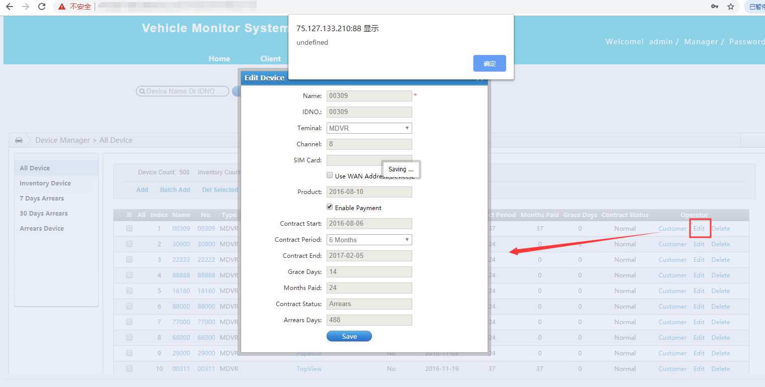

When we got this error, it menas the SIM card num had been used, it can not be None, you just need to fill in the SIM card num and make sure it do not same as others, then you can change the device parameters, and save it.

