How to solve the blurred image of playback

​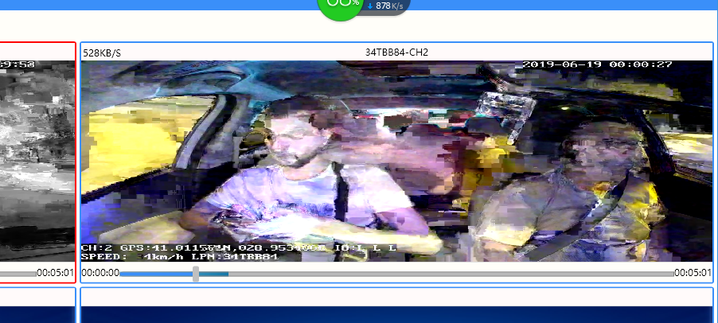

Click the "Open file location"> turn on the "NewClientWpf.exe.confing" >Ctrl+f"RecordUseSDL">change the value from 1 to 0.

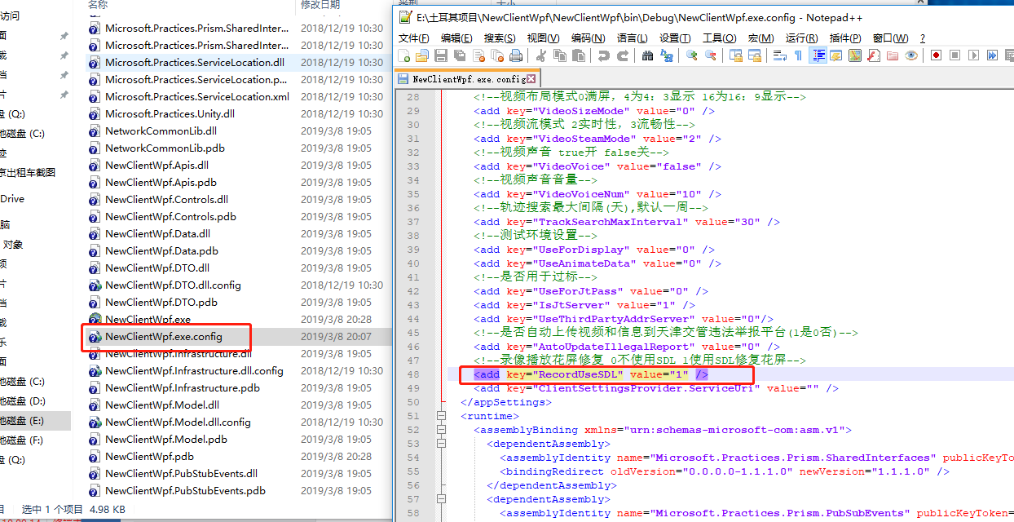

Then you can see the image was clear and Fluent.

