How to solve the web report can not show location

1. First, open the IVMS Server installation directory, find this file and replace it.

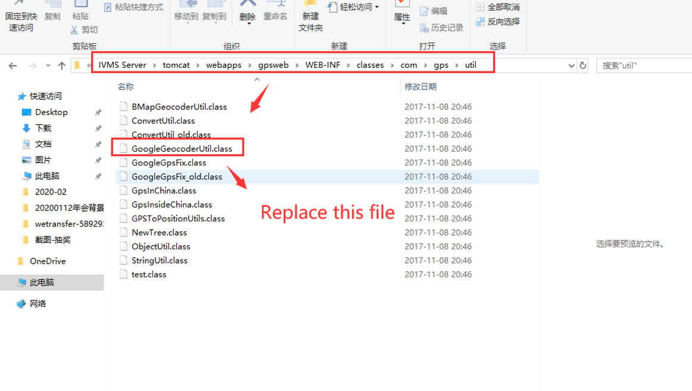

2. Then find this file, and replace it , also add your google API key at this side.

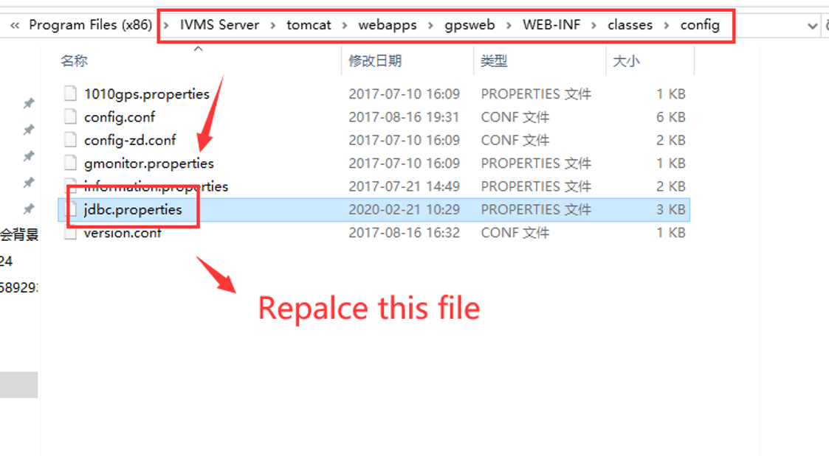
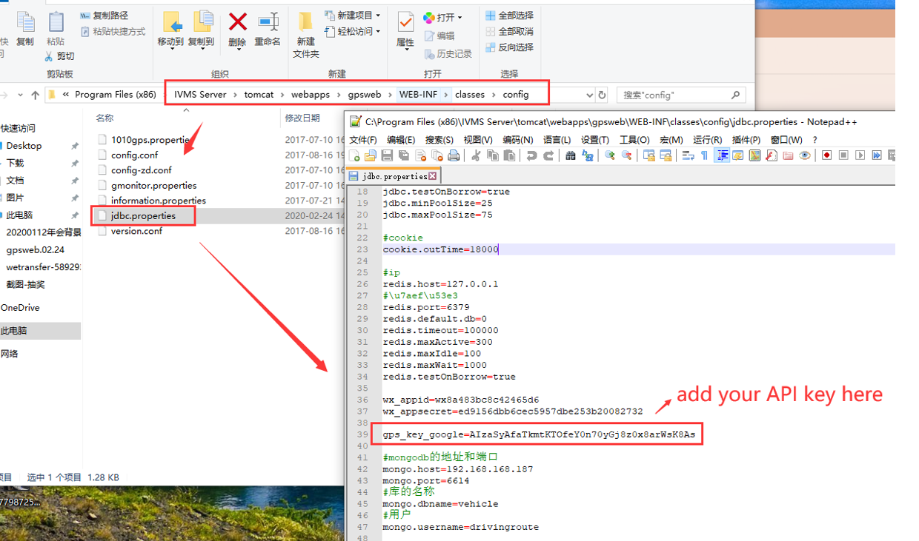
​
3. Restart the IVMS Server and check the report again, you will find it is working now.

Notice: You can get the replace file and manual from the attachment.
gpsweb.02.24.zip

