How to get your forgotten password of IVMSClient

​There are the steps about how to get the forgotten password of IVMSClient.

1. Kindly download the Navicat for MySQL via the link.
https://www.dropbox.com/sh/a44t2tv3o78jok4/AAA6vG9AeX1yeDamAwcfMiSka?dl=0

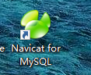

2. Here is the Registration code: NAVA-RFZU-JCSR-P3E8 ; Or NAVL-EHNC-7N7P-W6GM.

3. Please type the account info as below. the password is cmsserverv6.

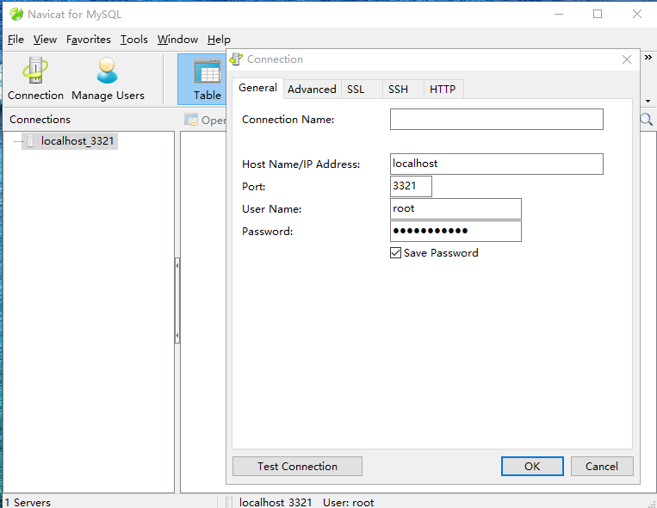

4. Please click the account table. Then copy the Ciphertext of the password.

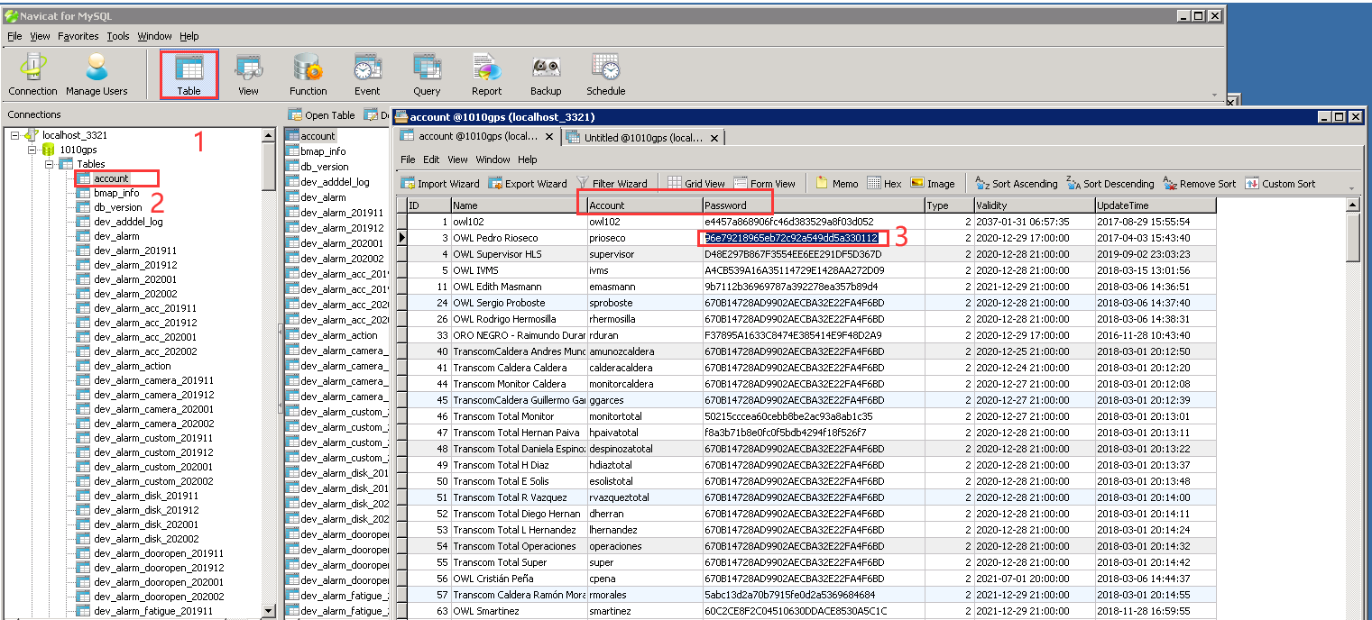

5. Surf the link: www.cmd5.com. Then exchange the Ciphertext to the password.

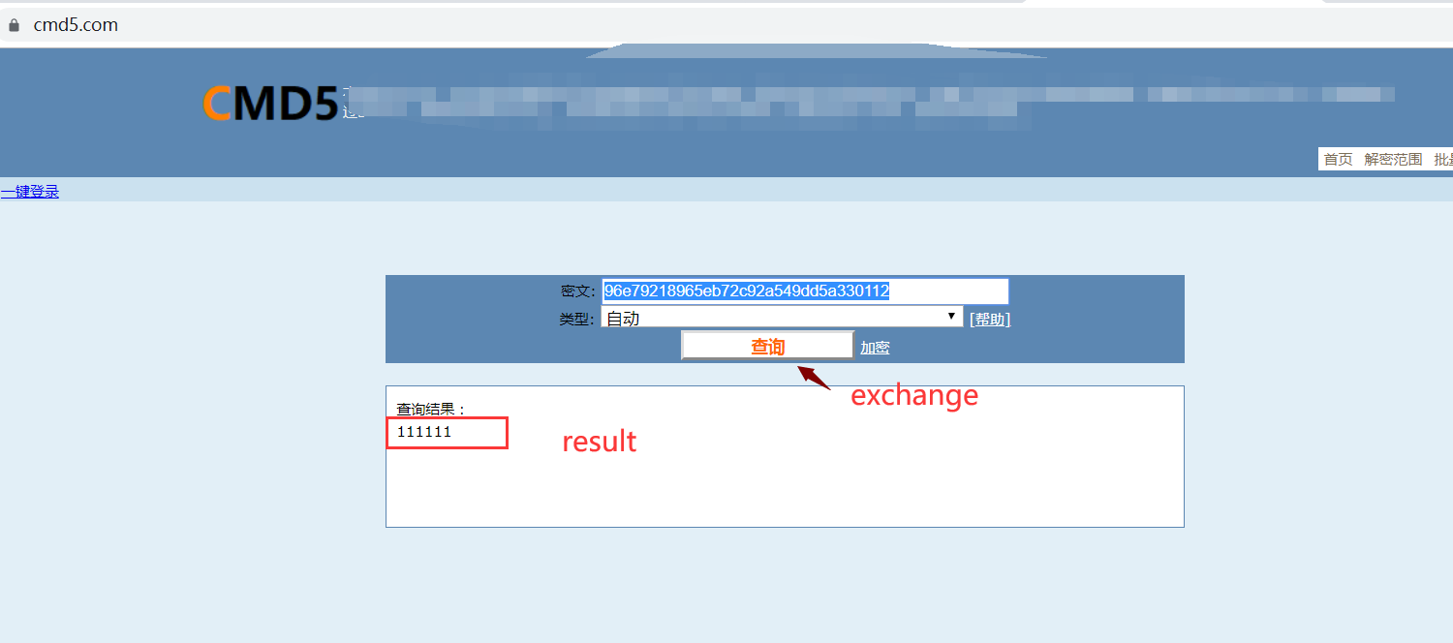

6. Finally, you can fill the password and the account and login the IVMSClient.

