How to adjust the volume of Analog intercom

​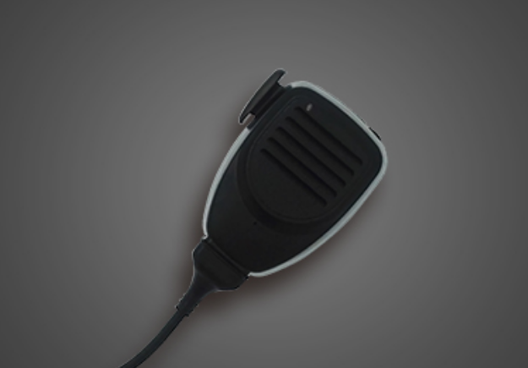

1. When first use this Analog intercom, some clients will think the volume of the intercom is too high, if want to adjust the volume of the intercom, it needs go to the MDVR menu and find the following config page.

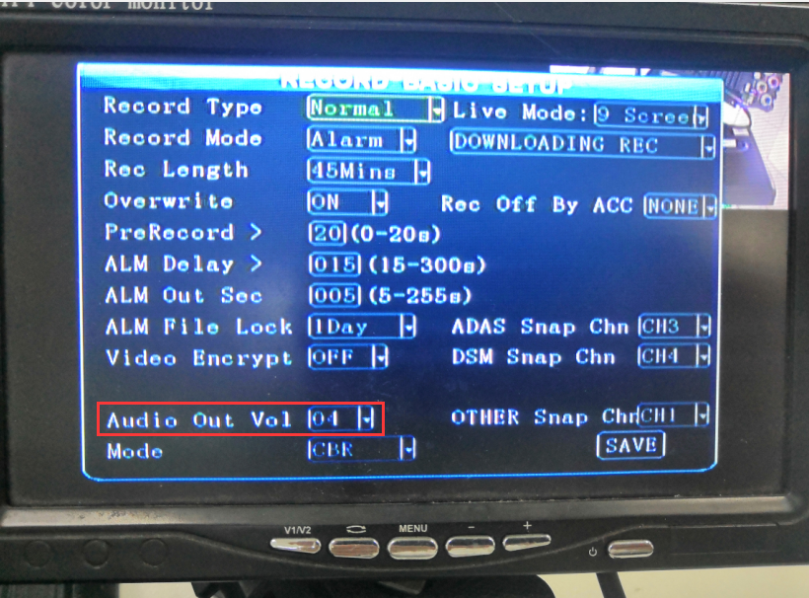

2. Find Audio Out Vol, and if need turn up the volume, choose the large value. And then save it.

Notice: Not every firmware version support adjust the volume, the old version maybe not support, so before adjust this or when after change it, it can not help, please share us the firmware version, and we will help check the version.

