How to solve HTML5 Media Server run failed

​There is an OS issue "0xc000007b"， which will cause the HTML5 Media Server run failed.

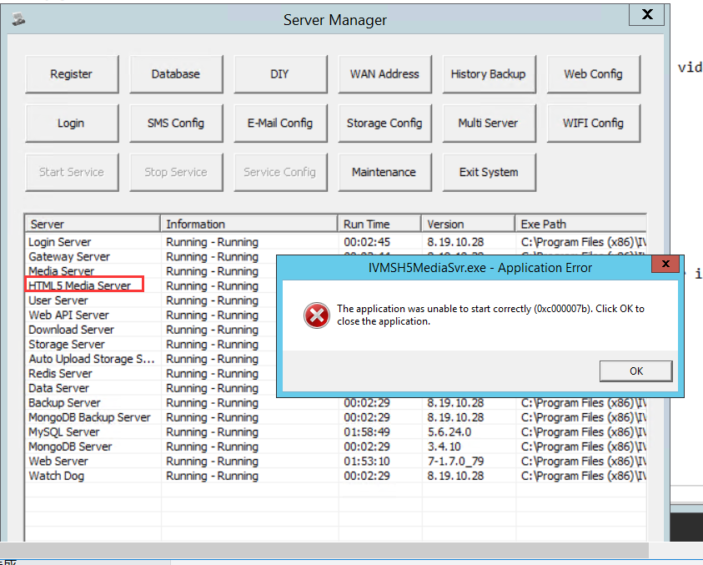

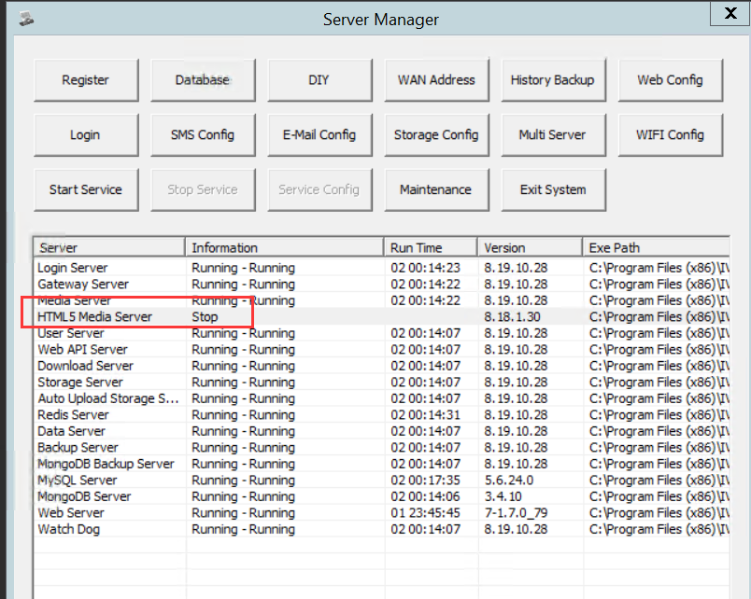

Kindly download the follow four progresses and install them.
vc_redist.x64.rar
vc_redist.x86.rar
vcredist_x86.rar
vcredist_x64.rar

After that. The HTML5 Media Server will work normally.

