How to solve the Media Server restart repeatedly

​If your Media Server restart repeatedly as below. ( Its' Run time always are several minutes.)

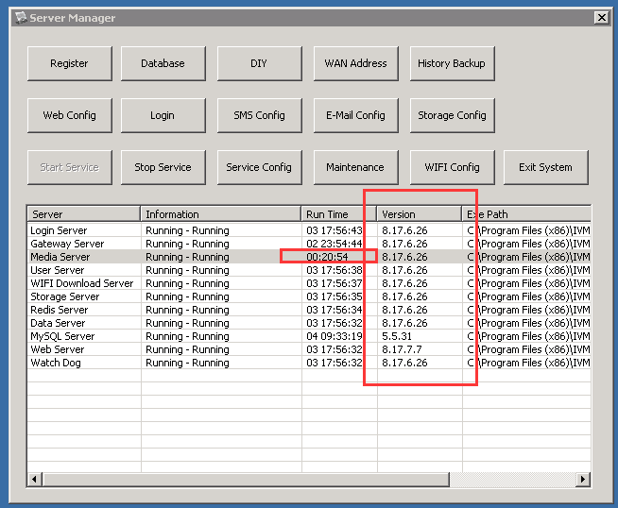

Please follow the below steps to solve the issue.
1. Kindly download the folder via the link and Unzip it.
https://www.dropbox.com/s/tol5r0jhra2u7vj/update-bin-20180207.rar?dl=0

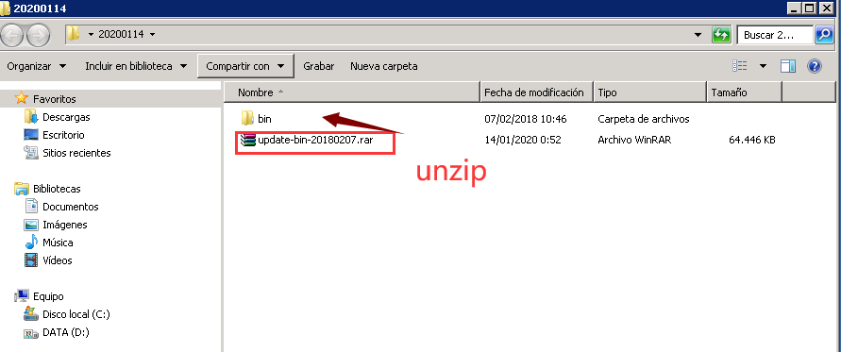

2. Exit system.

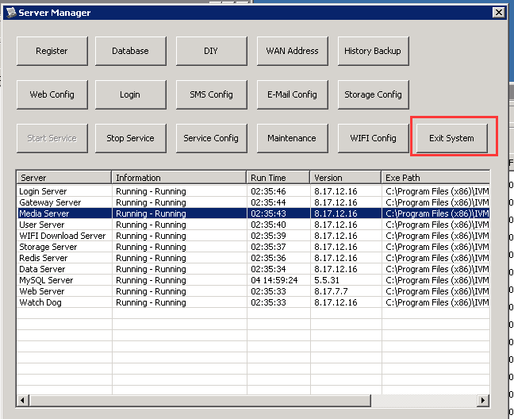

3. Copy all the files and folders of the bin you downloaded to IVMSServer/ bin. Then choose replace.

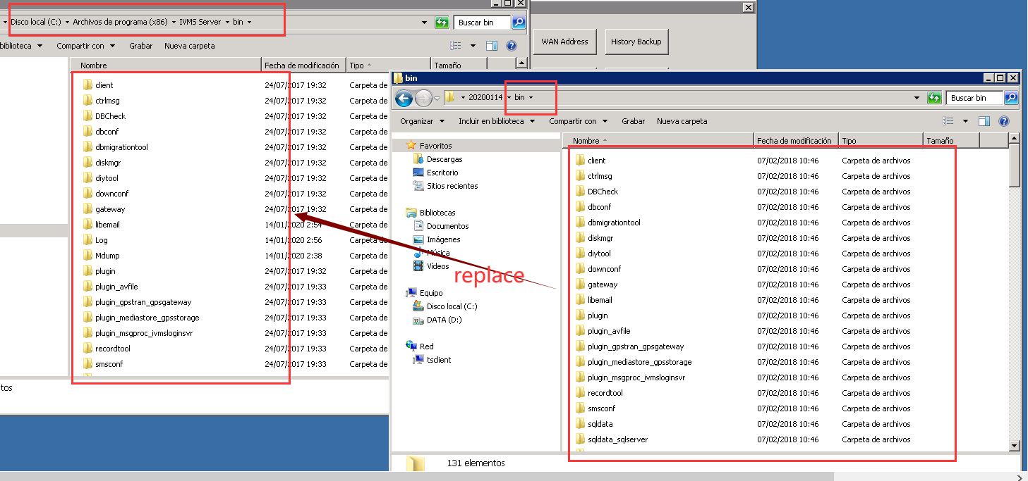

4. Double click the IVMSServer to turn it on. Runing several hours to check if the Media Server work normally.

