Introduction of the front led lights to the MDVR

​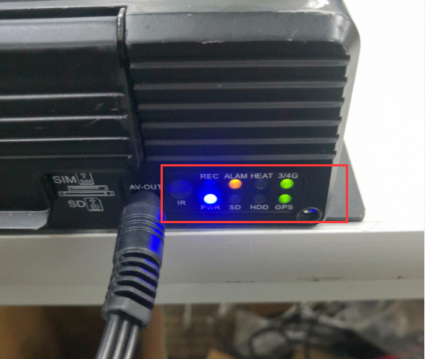

The led lights rules:
- POW-- If the power is on, the light will be bright.
- REC-- If one or more channels work well, it will be bright, if config all channels to stop record, it will be off.
- HDD-- If the HDD works, it will be flash frequently, if the HDD is broken or not works, it will be off.
- 3G/4G-- If the 3G or 4G moduel exists, it will be bright.
- HEAT-- The HDD has the heat function, if it starts to work, the HEAT light will be bright.
- GPS-- The GPS light will be bright, if the GPS moduel esixts.
- SD-- If the device was inserted the SD card, it will be bright.
- ALARM-- If the device alarms occured, it will be bright, such as HDD is fault, IO alarm, G-sensor, high temperature etc.

