4G State Dialing failed

​There is a strange phenomenon:
The 4G-State keep dialing and no dialing as the below picture.

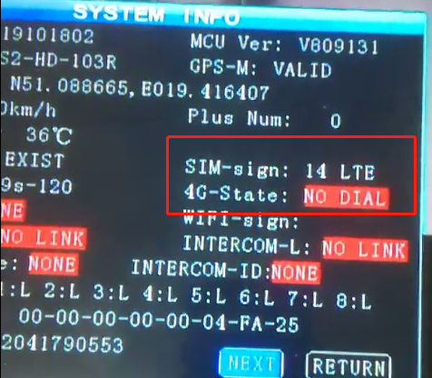

1. Please check your 4G parameters, such as APN, Type. etc.

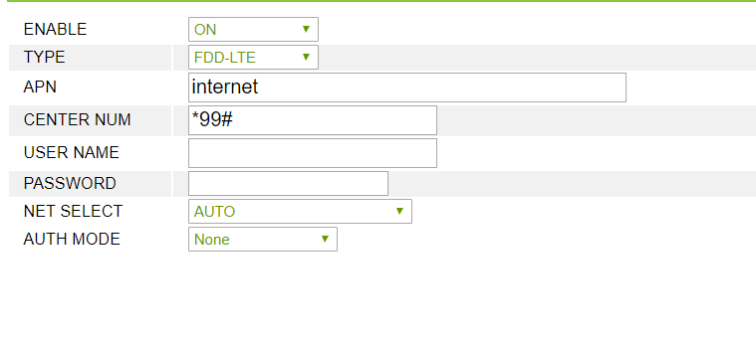

2. You can also import the config file from the other device which is dialing successfully.

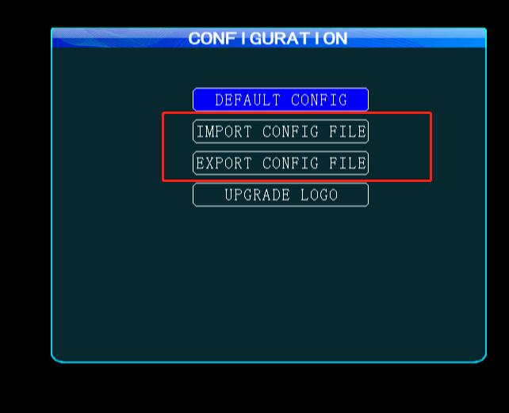

3. Change another SIM card for a try.
4. Please make sure the 4G signal was not poor. The 4G anttena connected well to MDVR.
5. If all the above methods are tried, please send the debug-log and netdebug-log to our engineer to check.

