How to use CWD10 write RFID card

1. First, you need to use the USB cable connect CWD10 to your PC, then it will install the drive itself.

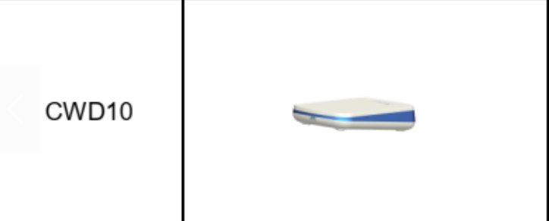
2. Open the Cardwriter software, if CardWriter.exe dose not run , plese run vcredist_x86.exe to install runtime library.

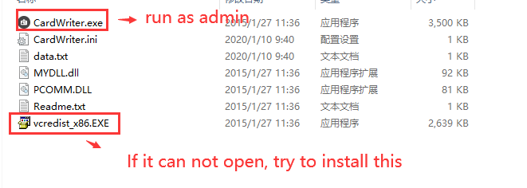
3. Put the card on the CWD10, if you want to know the RFID card information, you can choose Read to show the card information, if you want to write a new ID, you can change it to what you want and choose write to set it.

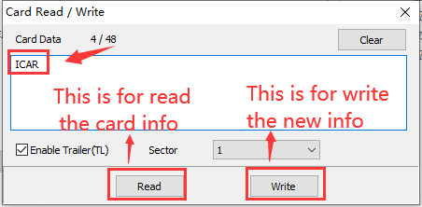

4. After this, you can swipe the card at RFID side, then we will get the information from IVMS client.
CardWriter.rar

