Video surveillance camera focal length, angle, distance reference value

Usually ordinary surveillance cameras, under the same series of products, often provide lens specifications of 3.6mm, 4mm, 6mm, 8mm, 12mm and other specifications. Then when we purchase a surveillance camera, in addition to the sharpness index, the focal length of the lens is also a key parameter. When purchasing, you need to choose a surveillance camera with a proper focal length according to the actual use situation.

Focal length: refers to the distance from the optical center of the lens to the focal point of the light when the parallel light is incident. The length of the lens focal length determines the size of the image, the angle of view, the depth of field, and the perspective of the picture.

Field of view angle: the angle between the two edges of the maximum range of the lens through which the object image of the measured object can pass through the lens as the vertex.

Depth of field: refers to the range of the distance between the front and back of the subject as measured by the imaging of the camera lens to obtain a clear image.

Lens, angle, visible distance (see the distance of the face)
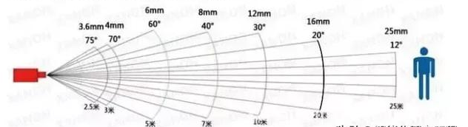

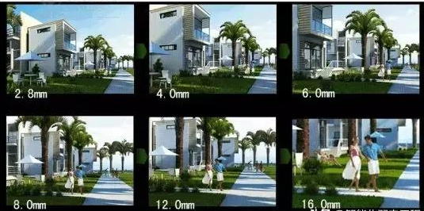

What is the effect of different focal lengths? What's the difference?

In simple terms:
- The smaller the focal length, the closer the viewing distance, and the larger the field of view.
- The larger the focal length, the longer the viewing distance, and the smaller the field of view.

Choose different focal lengths for different usage scenarios.
- For scenes with large field angles and small changes in object distance, a 2.8mm or 4mm lens can be selected.
- For scenes with larger field angles and larger object distance variations, 6-12mm lenses can be used.

Recommended monitoring distance for lenses with different focal lengths:
- The 2.8mm lens can be used in a monitoring environment with a narrow space such as a storage room, and the optimal monitoring distance is within 3m.
- The 4mm lens can be used in indoor environments such as small shops or homes. The optimal monitoring distance is 3-5m.
- The 6mm lens can be used in small shops or doorsteps, and the optimal monitoring distance is 5-10m.
- The 8mm lens can be used in outdoor roads and hutongs. The optimal monitoring distance is 10-20m.
- The 12mm lens main can be used to monitor specific positions, such as some specific entrances and exits, etc. The optimal monitoring distance is 20-30m.

Different devices have different FOVs, so the specific applicable distances will vary, depending on the actual parameters of the device.

