How to solve the issue of connecting to

database failed.
- There is a phenomenon that connection to the database failed as the below picture.

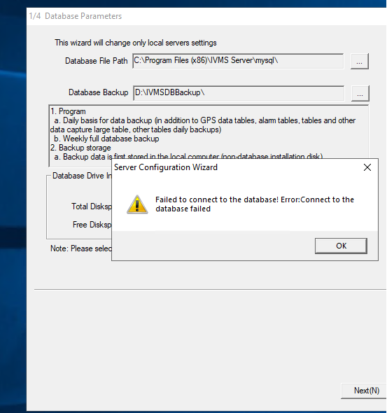

- Run the DBCheck.exe please.
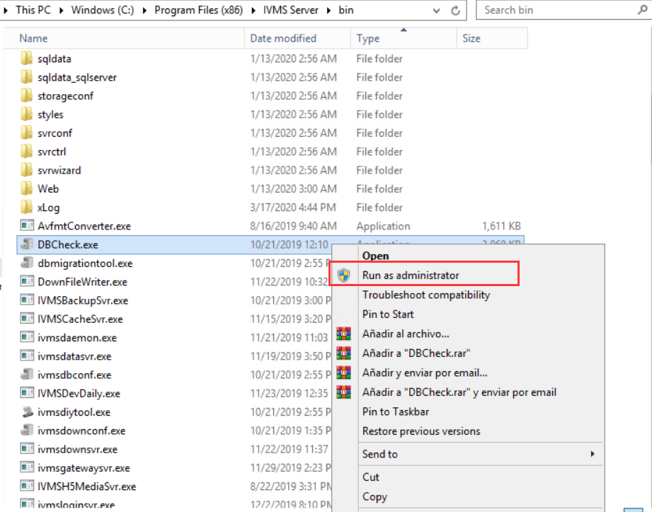
- After DB Check finished, run the IVMS Server please.

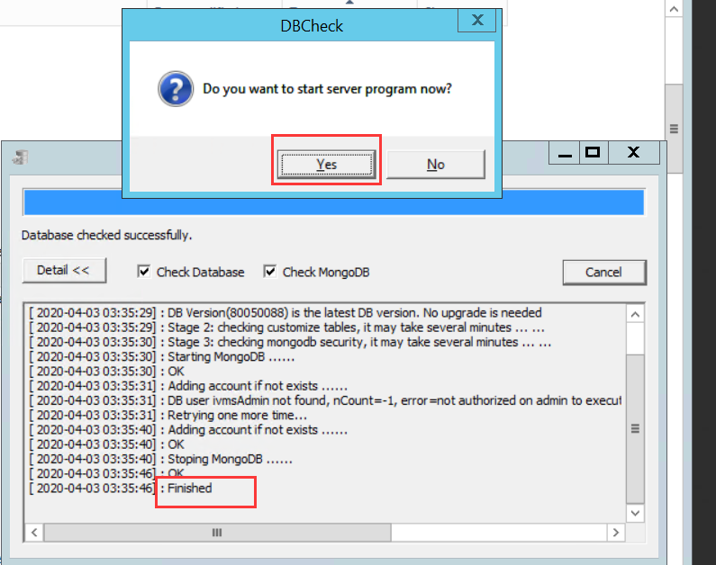
- Click the Database> DB Maintenance> Restore Database.
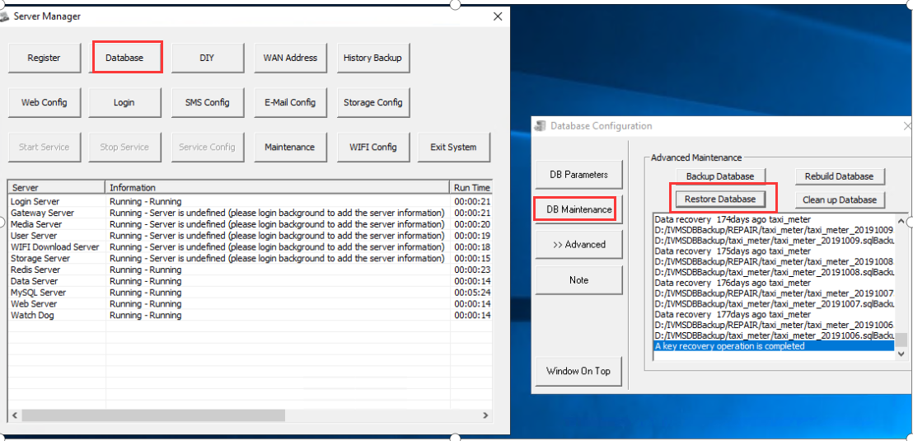
- After the Maintenance finished, please run the ivmssvrwizard.exe.
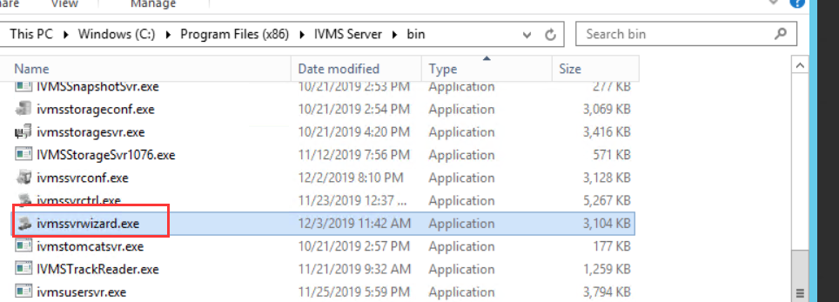
- All steps finished, IVMS Server will run normally.
