How to find the ACC cable of the vehicle

When install the MDVR on the vehicle, we need find the ACC cable, cause we need use ACC to control the MDVR like the following. Next, you can follow the steps to finish the task.
Tool:Test pencil，Key

Notice: Please do the settings with the professional engineer, and for different type of vehicle, it will be different. For some vehicles, under the audio control panel, it can use for the ACC.

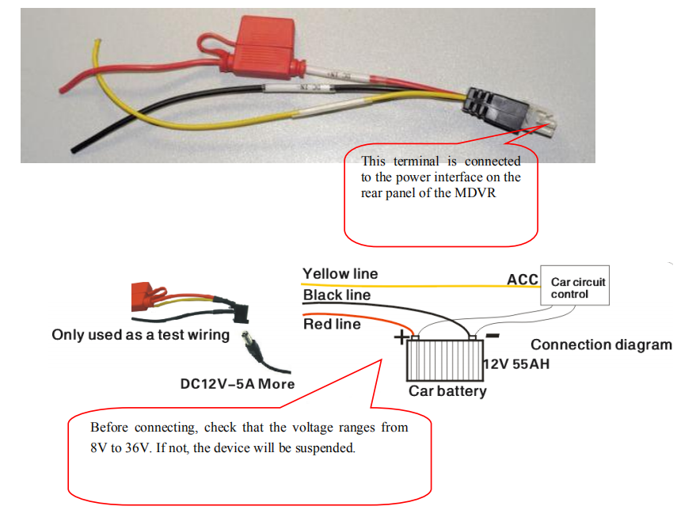

1. Normally, inside the vehicle, there exists contorl center of the vehicle system as shown. So, the way to find the ACC is that we can test the every button according to the different status of the ACC, when ACC OFF, we can test, which button is working, when ACC ON, which will be working, the status is different under the two ways.

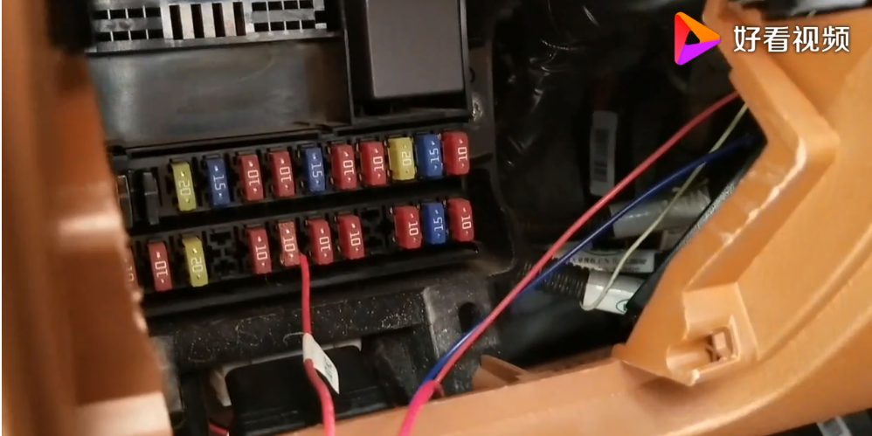

2. First we leave the ACC OFF, and use the test pencil to measure the every button, you can find some works.When if works, the light of the test pencil will be bright.

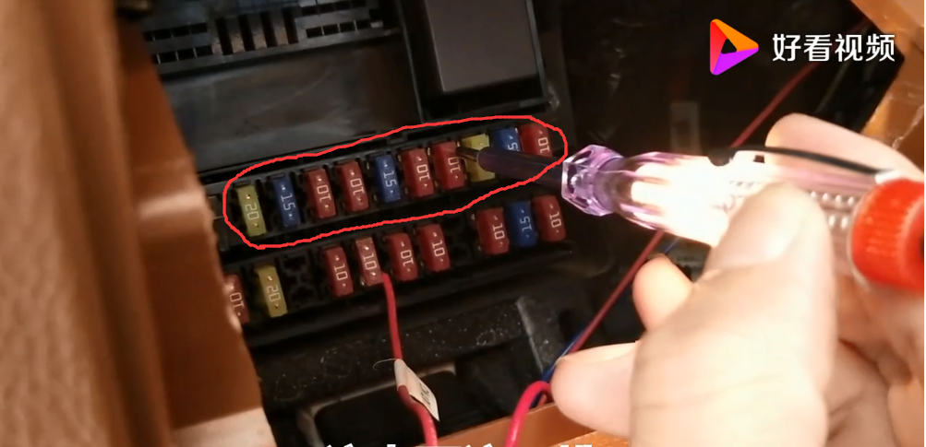

3. Second, make the ACC ON test do the same test.

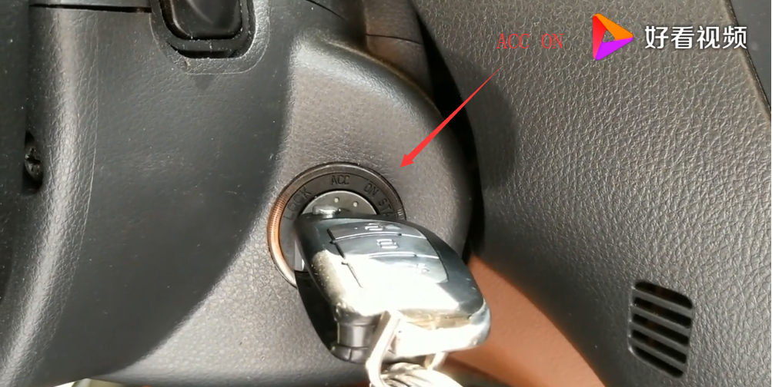

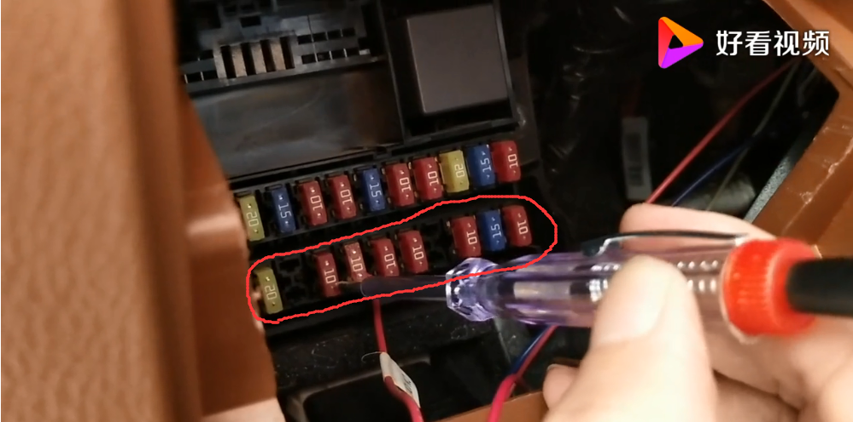
4. When the ACC ON, some control button will bright.Then the ACC cable will be found.

