Sound issue about video

There are some sound problems and their solutions.

1. There is no sound when you play the video.
Solution:
A. Please make sure your volume of your own PC and MDVRPlayer.
B. Please confirm the parameter " Audio " of MAIN CODE was ON.

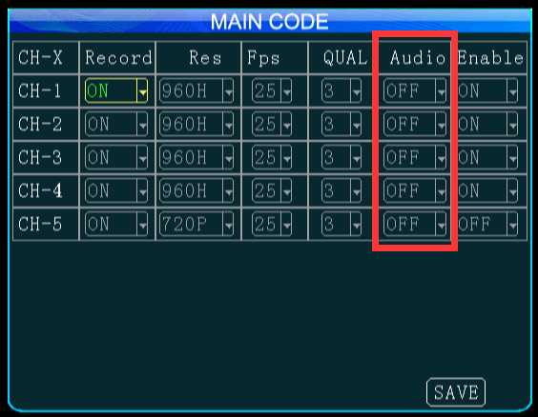

2. The sound was not synchronous with the video.
Solution:
A. Please provide us the software version number and we will test with the same software. If possible, you can try to update the firmware version.
B. Please provide us the video file, we need to analyze the source video.
C. Please contact technical support engineers for the latest MDVRPlayer version.

3. There was much noise with the video.
Solution:
A. If the sound issue from IP camera, please set the parameters as follow.
B. Please contact technical support engineers and provide the video file.

