The introduction of SATA cable

​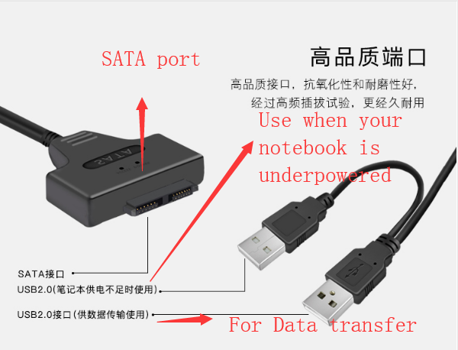

If the SATA cable is like this, it has two USB2.0 terminal, it means different, one is for the notebook, if you use notebook to read the SATA cable, sometimes you need use two terminals, cause one is not enough to get the proper power supply, but if you use PC, you can only use one cable, one main cable, to get power and transfer the data.

