How to change the Device Num in New IVMS side

​1.First, close the IVMS client, then open the IVMS installation directory, find the app.ini file.

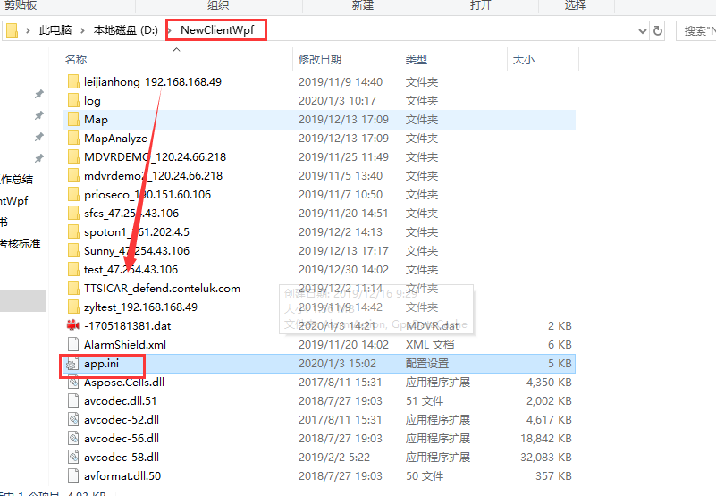

2. Open this file, and change CAN_EDIT_DEVICE_ID=0 to 1, then save it

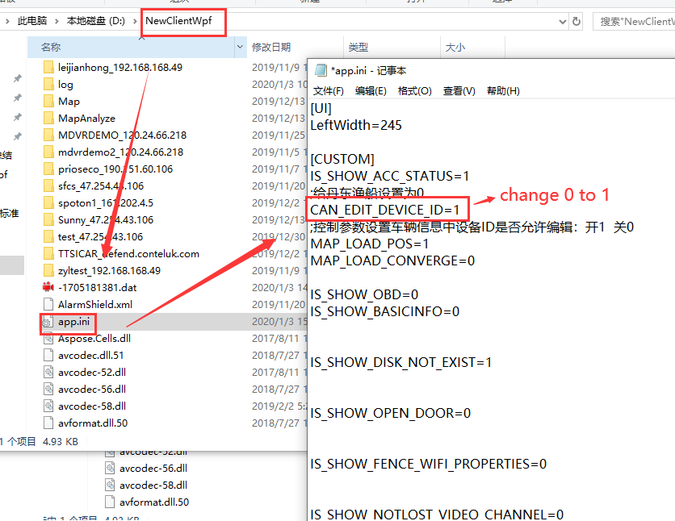

3. Open the New IVMS client, and login again, then choose the device to check if we can change the Device Num now.

