Batch Vehicle upgrade firmware

​Frist. Choose device and select " Batch Upgrade".

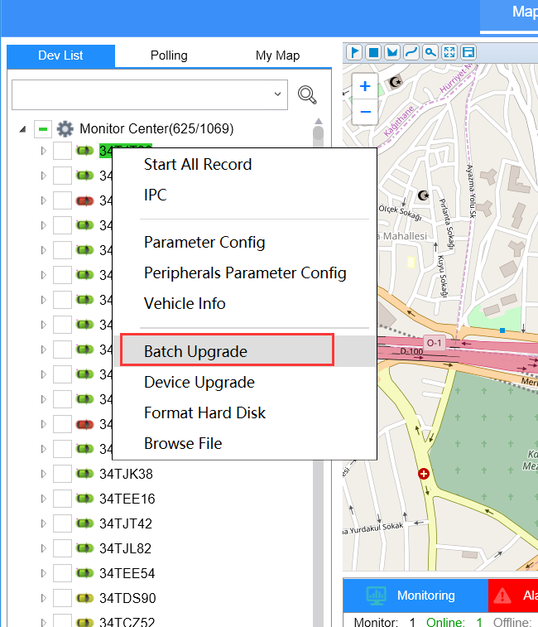

Second. Click the “ Get File”

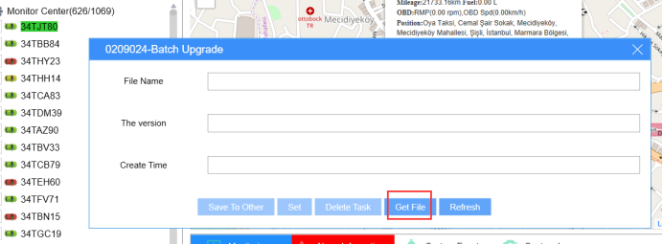

Third. Please upload the firmware file before you do the following steps.
Then double click the firmware.

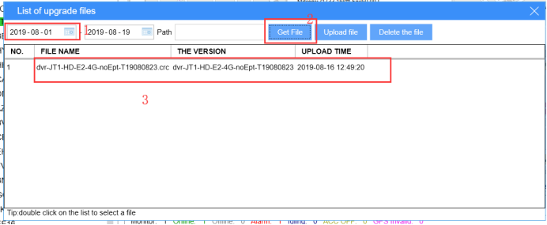

Fourth. Select the devices which you need and click " OK ".

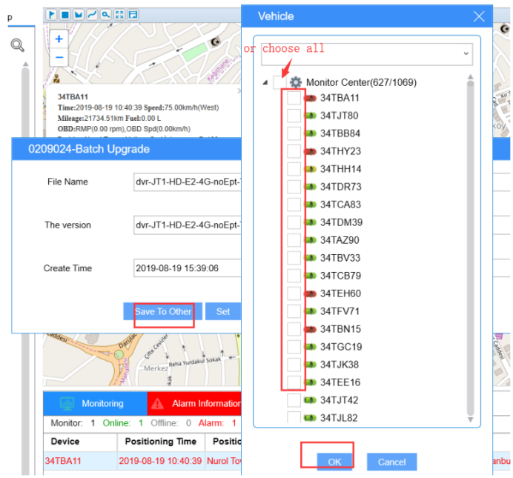

Finally. Please click the " set ". The firmware will be upgraded as long as it was online with the task.

