How to solve the IVMS Client Map show not safey

​When we add SSL certificate to server side, and all the data had encrypted, the web client side will working well, but when we login at IVMS Client side, it may be will show this error in map side, and say the link is not safety, then can not see the map.

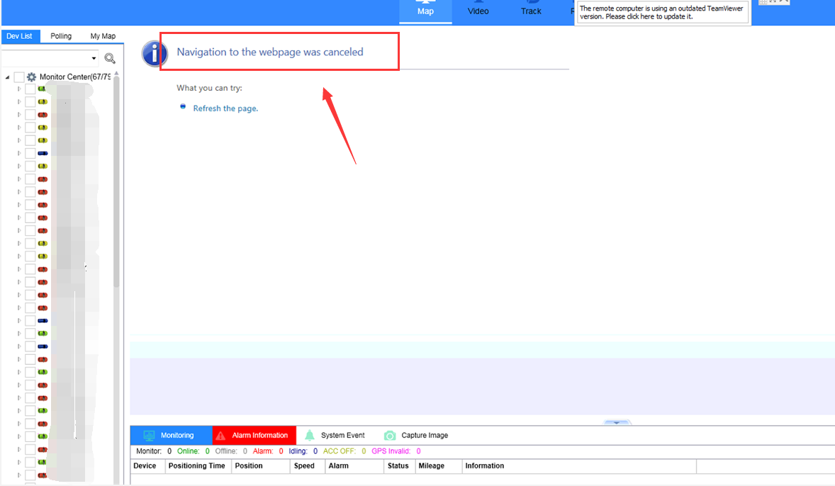

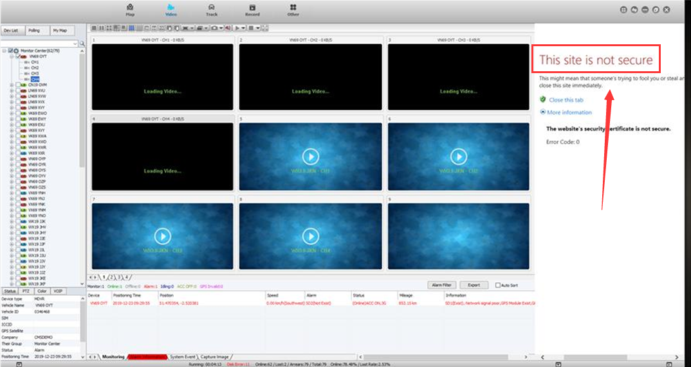

You need to check you are use IP login or Domain name login, because the SSL certificate is bound to the Domain name side, soyou need to make sure you had use the Domain name login, also you need to check the config file if the https had enableed and port is right or not.

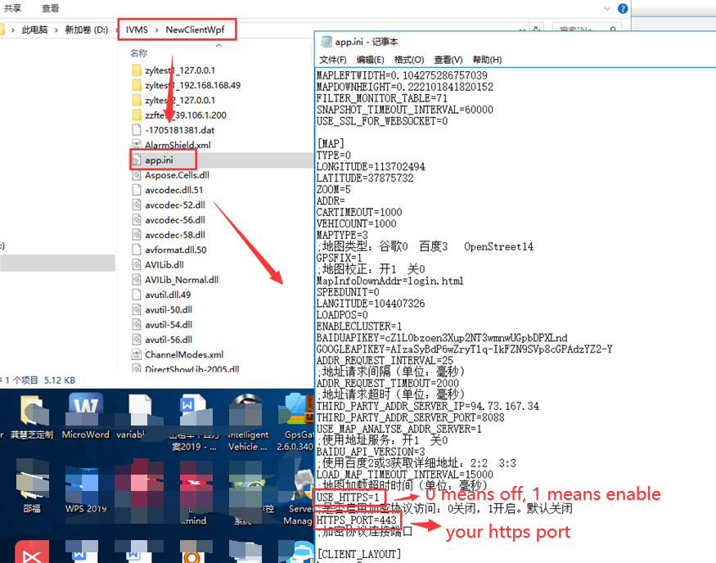

After this, login to the server side, then change the google file seetting, you can change it like this, then save it, restart the web server and clear the IE browser cache.

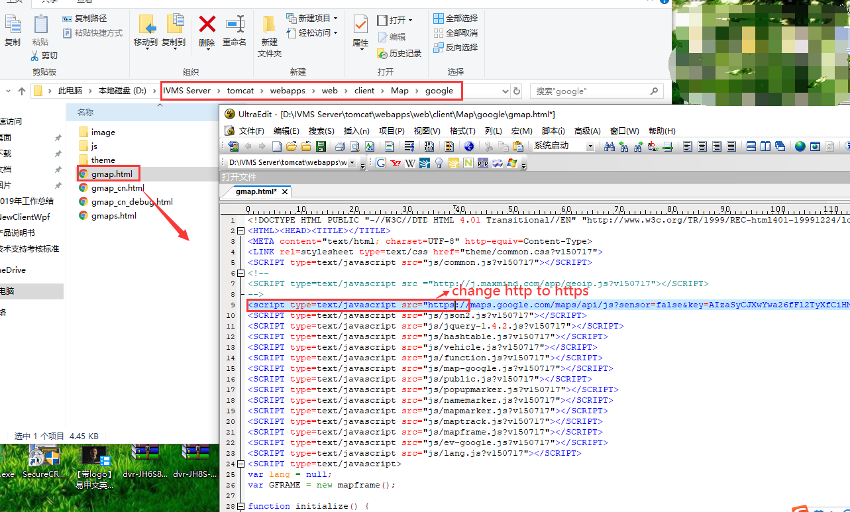

Restart the IVMS client, use Dmain name login again, then you will see the map is working now.

