How to use PC format the U disk to Fat32

- Sometimes, we maybe need U disk（USB flash drive） to export the videos, logs, but sometime when we need upgrade the firmware or MCU, we need use U disk， but U disk's format should be Fat32 mode.How ever if your U disk is not Fat32, it's NTFS, you can use PC to format it.
- Plug the USB flash drive into the computer.
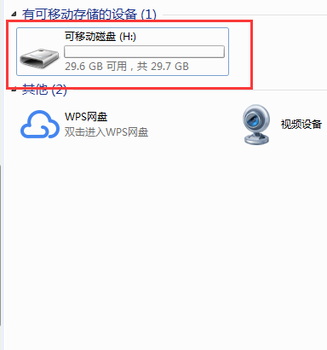
- Right click the Disk drive and find the mode of Fat32, and format it to Fat32, when use USB flash dirve to upgrade the firmware or MCU, it will be better to remove other files inside the drive, just remain the upgrade file inside the U disk.
