How to use remote control simulation speed

​1. First, make sure your MCU support this funtion, the newest MCU is V912302, if your MCU do not support this function, you can ask our technical support send you the newest MCU to upgrade.

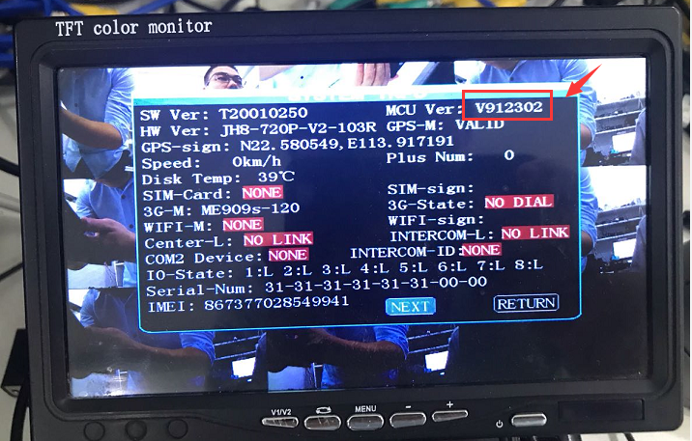

2. Login the device, then choose Alarm--Speed, set get speed from vehicle, and the cofficient to 3600, then save it.

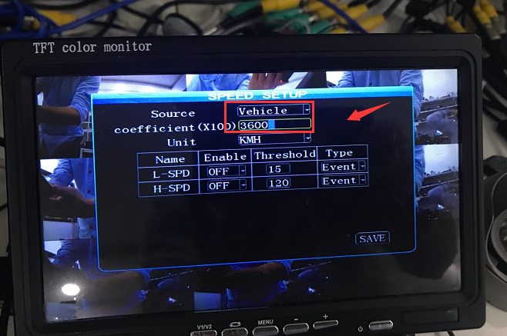

3. Back to the video page, then use the remote control enter 8+ F3+ F1+ 0/4/6/9, 0 means 0km/h, 4 means 40km/h, 6 means 60km/h, 9 means 90km/h, like this 8+ F3+ F1+ 6, it will show 60km/h, you can check it in system info page.

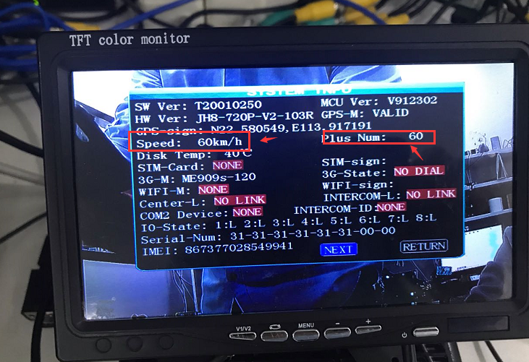

4. Ather this, you can use the device test ADAS or others which need speed to trigger alarm.

