How to solve web add device failed problem

​When we want to get more MDVR online, we always need to add more devices in Web side, when we add this, it may show us this error " Add Vehicles can not exceed the registered vehicles".

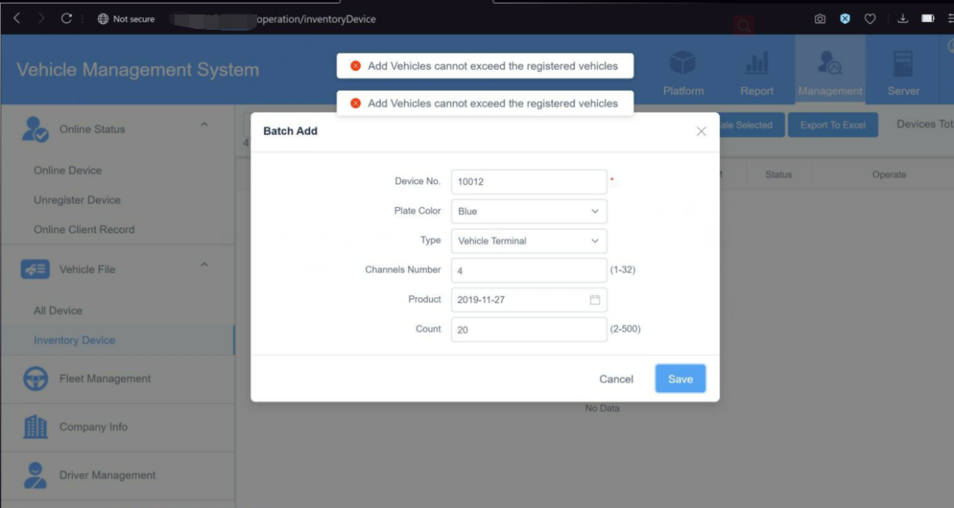

1. When we get this error, you can check if your license is less than the device you want to add or not, you can check it in this side, if you want to register more license, you need to give us your server IP and Signature, also the total license number, then we will use it register the licenses for you.

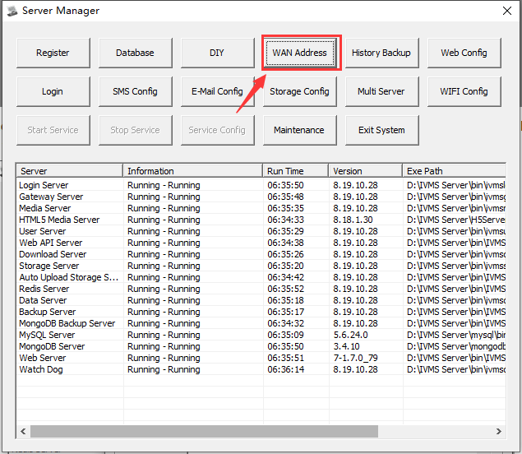

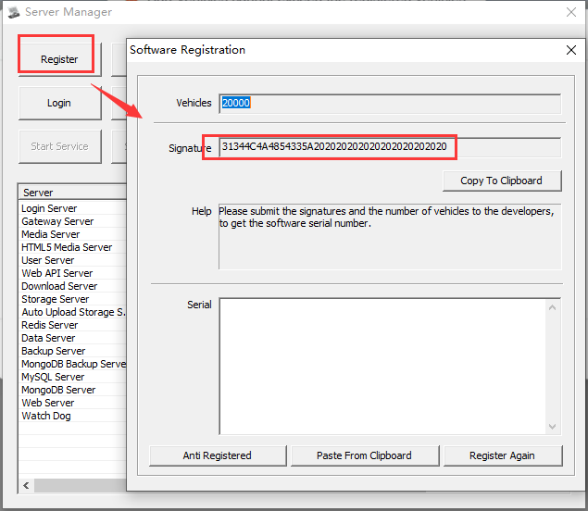

2. When you get the licnese code, you can add it in this place, then you will see your license number had changed.

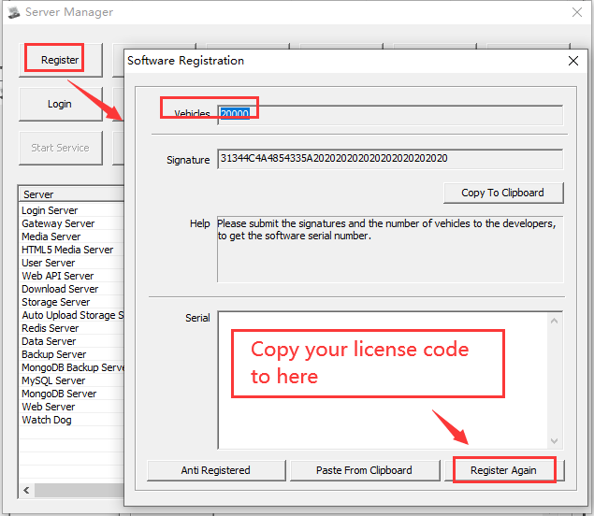

3. After doing this, the login server will restart, when it running again, then you can open the web page to add device, you will find it is working now.

