How to check ADAS and DSM alarm at Android APK side

1. First, you need to mark sure your server is the newest one, if your server do not support this, you can ask our technical support send you the newest version, then upgrade it to test this.

2. Install the newest APK version, if you do not have this version, you can ask our technical support send it to you, also it will update to Google Play later, open the APK, and use the account login.

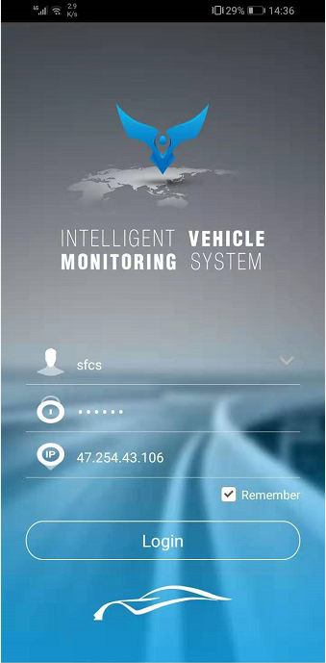

3. Choose Setting, then clike the Security Management, choose the device and date to search the alarm list.

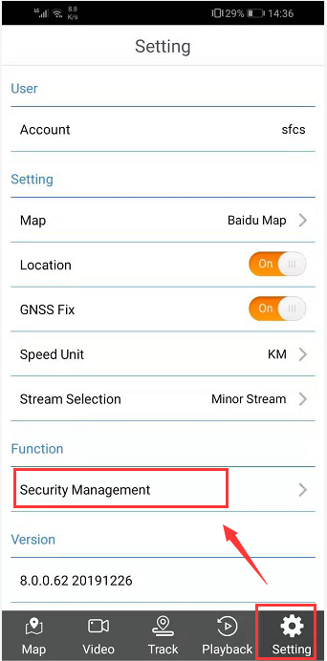

4. If it have data, it will show like this ,then you can check the alarm picture and alarm video.

