GPS Track Abnormal

There are several kinds of abnormal GPS trajectories and their solutions.
Phenomenon 1: The vehicle briefly crosses the ocean, buildings, etc.
​
Solution: View the interval between GPS trajectories. Whether GPS data is lost in the middle. It may be caused by server restart, device number conflict, poor GPS antenna contact, and weak GPS signal. You can see the picture as below, there are one munite GPS datas missing.

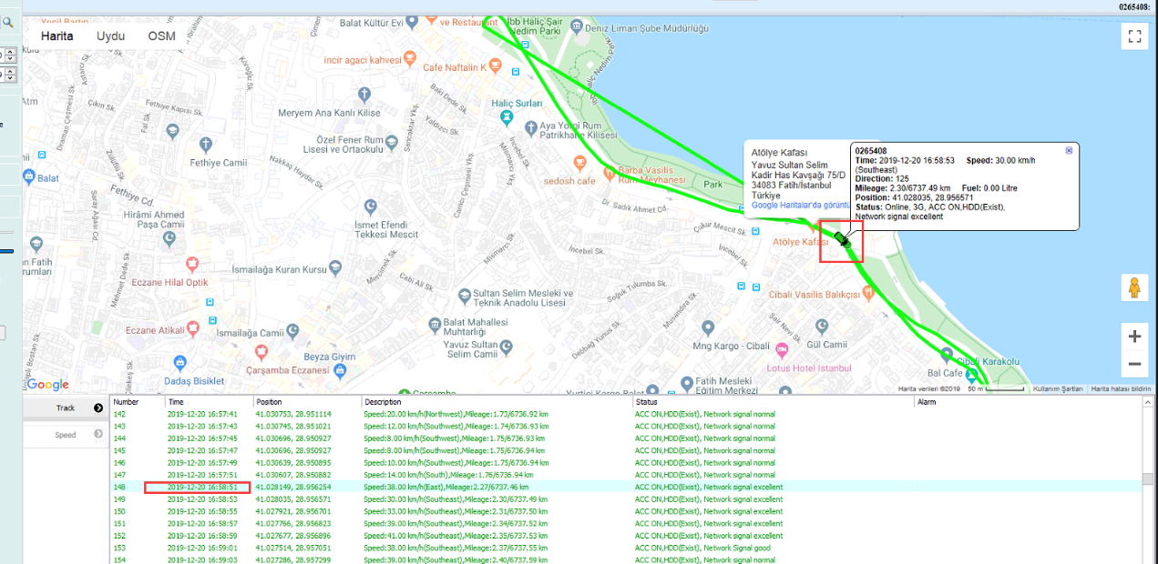

Phenomenon 2: The vehicle is shifting on both sides of the road.
Solution: A. Tick the GPS fix option.

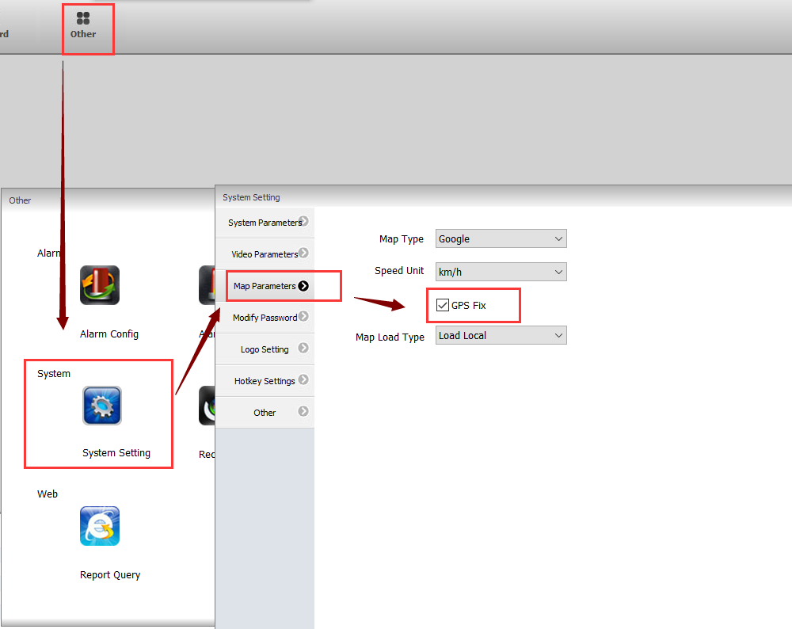

B. Shorten the time interval for the GPS upload of the MDVR. Our default is 10 seconds. You can choose 3 seconds or 1 second according to the actual situation.

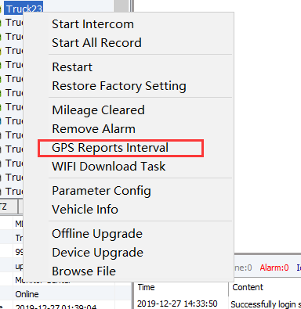

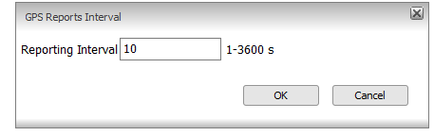

You can search the GPS track data to check if your configuration was successful.

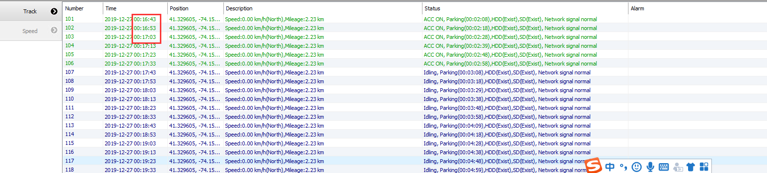

10s to 1s

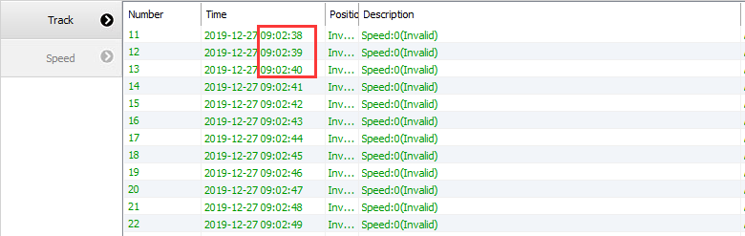

Phenomenon 3: The GPS trajectory is still not on the road.

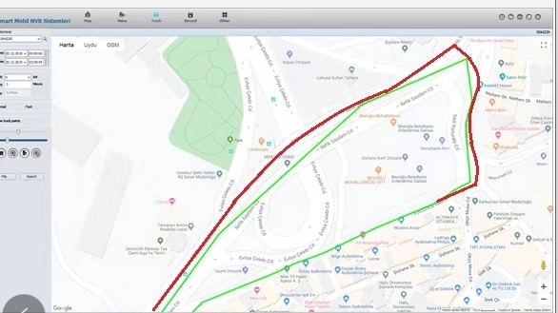

Please install the following tools.

ParseDatFile.rar

According to the device number and time, compare the latitude and longitude of the GPS trajectory of the IVMS and the original latitude and longitude. If there are differences, please contact our technical support engineer.

