The difference between H.264 and H.265

​What's H.265?
H.265 is a new video coding standard formulated by ITU-TVCEG after H.264. The H.265 standard surrounds the existing video coding standard H.264, retains some of the original technologies, and improves some related technologies.

The new technology uses advanced technology to improve the relationship between code stream, encoding quality, delay, and algorithm complexity to achieve optimal settings. Specific research contents include: improving compression efficiency, improving robustness and error recovery capability, reducing real-time delay, reducing channel acquisition time and random access delay, reducing complexity, etc. Due to algorithm optimization, H264 can realize standard-definition digital image transmission at a speed of less than 1Mbps; H265 can achieve 720P (resolution 1280 * 720) ordinary high-definition audio and video transmission using a transmission speed of 1 ~ 2Mbps.

H.265 is designed to transmit higher-quality network video in a limited bandwidth, and only needs half the original bandwidth to play the same quality video. This also means that our smartphones, tablets and other mobile devices will be able to directly play 1080p Full HD videos online. The H.265 standard also supports 4K (4096 × 2160) and 8K (8192 × 4320) ultra high-definition video. It can be said that the H.265 standard has made the network video keep pace with the "high resolution" of the display screen.

What's H.264?
H.264, also the tenth part of MPEG-4, is proposed by the Joint Video Team (JVT, Joint Video Team), which is a combination of the ITU-T Video Coding Experts Group (VCEG) and ISO / IEC Moving Picture Experts Group (MPEG). The highly compressed digital video codec standard. This standard is often referred to as H.264 / AVC (or AVC / H.264 or H.264 / MPEG-4 AVC or MPEG-4 / H.264 AVC), and it clearly states its developers.

The biggest advantage of H.264 is its high data compression ratio. Under the same image quality, the compression ratio of H.264 is more than twice that of MPEG-2 and 1.5 to 2 times that of MPEG-4. For example, if the size of the original file is 88GB, it will become 3.5GB after compression using the MPEG-2 compression standard, and the compression ratio will be 25: 1, and it will become 879MB after compression using the H.264 compression standard, from 88GB to 879MB. The compression ratio of H.264 reaches an amazing 102: 1. Low bit rate plays an important role in the high compression ratio of H.264. Compared with compression technologies such as MPEG-2 and MPEG-4ASP, H.264 compression technology will greatly save users' download time and Data traffic charges. It is particularly worth mentioning that H.264 has a high compression ratio and high-quality and smooth images. Because of this, H.264 compressed video data requires less bandwidth during network transmission. And more economical.

For the H.264 encoding format, according to different resolutions, the corresponding code rate configuration relationship is recommended as shown in the following figure:
Widescreen:

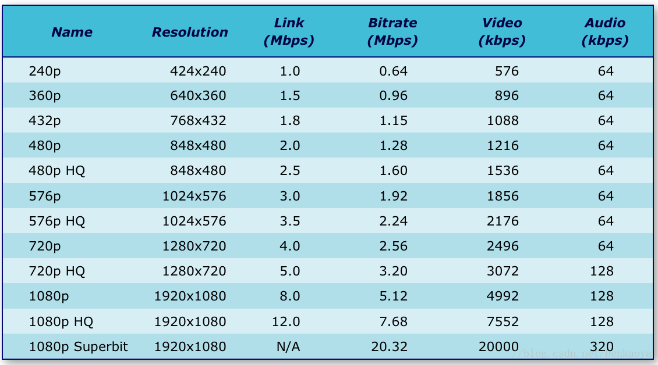

Non-widescreen：

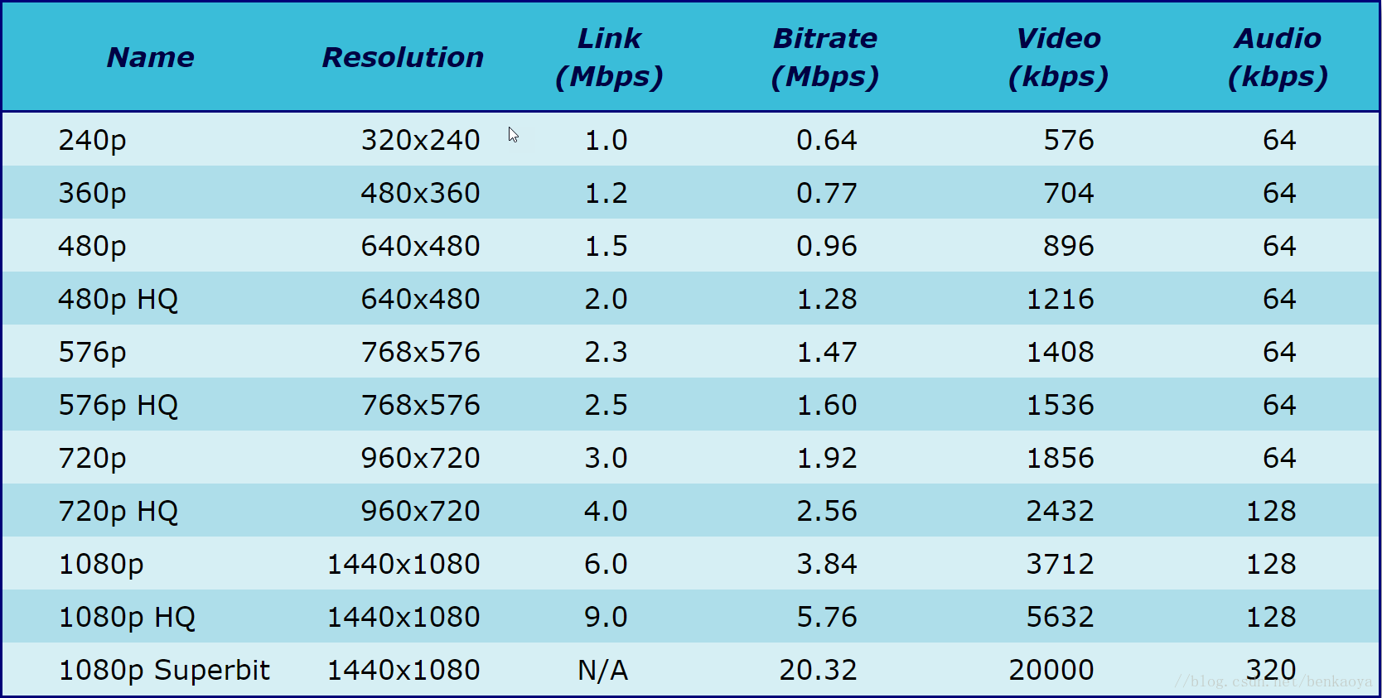

3. What's difference between H.264 and H.265?
Before discussing the enhancements and advantages of H.265, let's take a look at H.264 first. H.264 is also called MPEG-4 AVC (Advanced Video Coding, Advanced Video Coding). It is a video compression standard, and it is also a widely used high-resolution video recording, compression, and distribution format. H.264 is famous for being a codec standard for Blu-ray discs. All Blu-ray players must be able to decode H.264. More importantly, because Apple Inc. resolutely abandoned Adobe's VP6 encoding and chose H.264, this standard has entered millions of households with hundreds of millions of iPads and iPhones, and has become the current video encoding field. Absolute hegemony, occupying more than 80% of the share. H.264 is also widely used in network streaming media data, various high-definition television broadcasts, and satellite television broadcasts. Compared with previous coding standards, H.264 has some new features, such as motion compensation for multi-reference frames, motion compensation with variable block size, and intra prediction coding. By using these new features, H.264 has more advantages than other coding standards High video quality and lower bit rates have also been recognized by people and widely used.

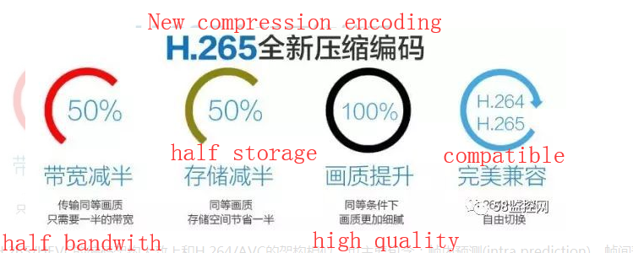

The coding architecture of H.265 / HEVC is roughly similar to that of H.264 / AVC, and it also mainly includes: intra prediction, inter prediction, transform, quantization, Deblocking filter, entropy coding and other modules. However, in the HEVC coding architecture, the whole is divided into three basic units, which are: a coding unit (CU), a prediction unit (PU), and a transformation unit (TU).

4. Why H.265 is better?
Compared with H.264 / AVC, H.265 / HEVC provides more different tools to reduce the bit rate. In terms of coding units, the smallest is 8x8 to the largest is 64x64. The area with little information (the color change is not obvious, such as the red part of the car body and the gray part of the ground) is divided into larger macroblocks, fewer code words after encoding, and macros divided in places with more details (tires) The blocks are correspondingly smaller and more, and there are more codewords after encoding. This is equivalent to the important encoding of the image, which reduces the overall bit rate and improves the encoding efficiency accordingly. At the same time, H.265's intra prediction mode supports 33 directions (H.264 supports only 8 types), and provides better motion compensation processing and vector prediction methods.

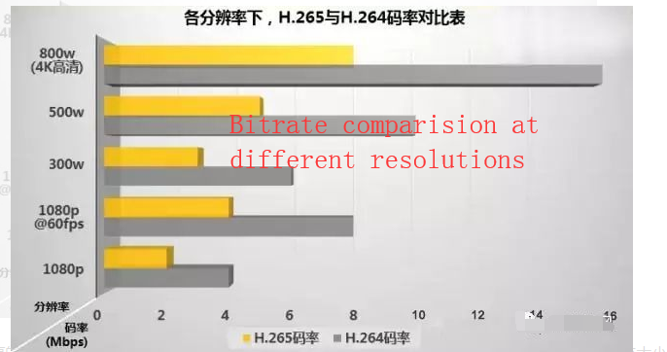

Repeated quality comparison tests have shown that, at the same image quality, compared to H.264, the video stream size encoded by H.265 is reduced by about 39-44% compared to H.264. Due to different quality control methods, this data will change accordingly. The data obtained through subjective visual tests show that with a 51-74% reduction in bit rate, the quality of H.265 encoded video can still be similar to or better than H.264 encoded video, which is essentially better than expected The signal-to-noise ratio (PSNR) is better. The criteria for these subjective visual tests cover many disciplines, including psychology and human visual characteristics. Video samples are very extensive. Although they cannot be used as final conclusions, they are also very encouraging results.

The current HEVC standard has three modes: Main, Main10 and Main Still Picture. Main mode supports 8-bit color depth (that is, red, green, and blue colors each have 256 chromaticities, for a total of 16.7 million colors). Main10 mode supports 10-bit color depth and will be used on ultra high-definition television (UHDTV). The former two limit the chroma sampling format to 4: 2: 0. It is expected that the standard will be expanded in 2014, and it will support 4: 2: 2 and 4: 4: 4 sampling formats (that is, it provides a higher degree of color reproduction) and multi-view coding (such as 3D stereo video coding).

In fact, the H.265 and H.264 standards have some overlap in various functions. For example, the Hi10P part of the H.264 standard supports 10-bit color-depth video. On the other hand, the H.264 part (Hi444PP) can also support 4: 4: 4 chroma sampling and deeper than 14 features. In this case, the difference between H.265 and H.264 is that the former can use less bandwidth to provide the same function, at the cost of device computing power: H.265 encoded video requires more computing power To decode. At present, a chip supporting H.265 decoding has been released. Broadcom released a Brahma BCM 7445 chip at the CES show in early January this year. It is a quad-core processor with a 28-nanometer process. , Can transcode four 1080P video data streams or H.265 encoded ultra-high-definition video with a resolution of 4096 × 2160 at the same time.

The birth of the H.265 standard is to transmit higher quality network video under limited bandwidth. For most professionals, the H.265 coding standard is no stranger. It is a video coding standard developed by ITU-TVCEG after H.264. The H.265 standard is mainly based on the existing video coding standard H.264. In addition to retaining some of the original technologies, it adds relationships that can improve the code stream, encoding quality, delay, and algorithm complexity. Related technologies. The main contents of H.265 research include improving compression efficiency, improving robustness and error recovery capability, reducing real-time delay, reducing channel acquisition time and random access delay, and reducing complexity.

How to calculate video storage under H.264 and H.265 technology?
① h.264 technology hard disk capacity calculation：
When it comes to calculations, what do we need to calculate? In addition to the number of cameras and the time required to record, there is another important value: the bit rate! In general, the larger the resolution, the larger the code stream, such as The 130W camera we commonly use, the code stream is 2MB / S, which is 2048kbps. Then knowing the code stream, time, and channel number, we can directly apply the formula to calculate.
The formula is as follows: Bit rate × 3600 × 24 ÷ 8 ÷ 1024 ÷ 1024 = 1D (one day)

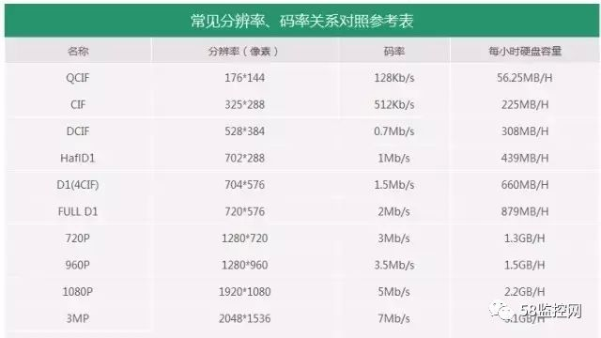
Code stream table

The code stream should be measured in seconds, so our capacity must be converted in seconds. 3600 is 1 hour, 24 is 24 hours a day, 8 is byte, and 1024 is the code stream MB is the unit, so if you want to convert G, you need to divide by 1024, if you change to T, you need to divide by 1024. The result is 1 day. How long does Party A need to store and multiply by the number of days.

② H.256 technology hard disk storage calculation
Under H.264 technology, one month of 4 300W storage is approximately: 60G * 4 * 30 = 7.2T
Under H.265 technology, one month of 4 300W storage is approximately: 30G * 4 * 30 = 3.6T

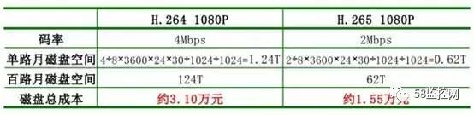

This is still stored, let's look at the bandwidth again. In the past, if H.264 wanted to watch a 130W pixel high-definition picture remotely, it would need 6M uplink bandwidth, while under H.265, a 4M network could watch a 300W high-definition picture. Two 200W screens.

Therefore, the cost reduction is not only for hard disk storage, but also for switches.

a. How to use H.265-enabled devices?
Can I use the old camera to connect to the H.265 video recorder, and the storage can be halved? No, for network cameras and video recorders, both parties need to support H.265 technology.
If one party supports it, the other does not? Rest assured, like other technical equipment, it is backward compatible, that is to say, except that the storage halving cannot be achieved, other functions are normal.

b. how to calculate H.265 storage?
Ordinary cameras are about 21G a day, can it be directly divided by 2? actually not. Here's a cleaner way!

200W≈20G
300W≈30G
400W≈40G

