Difference between Canbus and OBD

​CAN-bus (Controller Area Network) is the controller area network, which is one of the most widely used field buses in the world. At first, CAN-bus was designed to communicate between microcontrollers in the automotive environment, and exchange information between ECUs on the vehicle to form an electronic control network for the vehicle. It is a multi-master serial communication bus. The basic design specifications require a high bit rate, high immunity to interference, and the ability to detect any errors that occur. When the signal transmission distance reaches 10Km, it can still provide data transmission rates up to 5Kbps. Because CAN serial communication bus has these characteristics, it is naturally widely used in automobile, manufacturing and aviation industries.

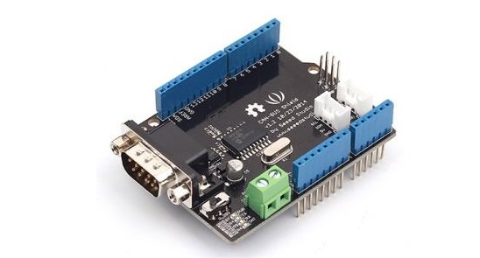

OBD is the abbreviation of English On-Board Diagnostics, and the Chinese translation is "on-board automatic diagnostic system". This system will monitor the car's exhaust gas at any time from the running status of the engine. Once it exceeds the limit, it will immediately issue a warning. When the system fails, the MIL lamp or Check Engine warning lamp lights up, and at the same time, the powertrain control module (PCM) stores the fault information in the memory, and the fault code can be read from the PCM through a certain program. . According to the fault code, maintenance personnel can quickly and accurately determine the nature and location of the fault.

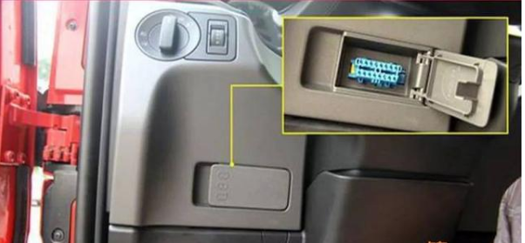

CAN-bus is a car (or any device using CAN-bus), the summation line (or interface) of various data, and is the data communication inside the car (such as the communication between the sensor and the ECU).

OBD is a global standard interface for connecting additional diagnostic tools.

Speaking of the simplest, C is internal data and O is external data.

