How to use pull box search function

​1.Open the IVMS Client, and use a account login, then find this option, click is and draw a rectangle to where you want to search.

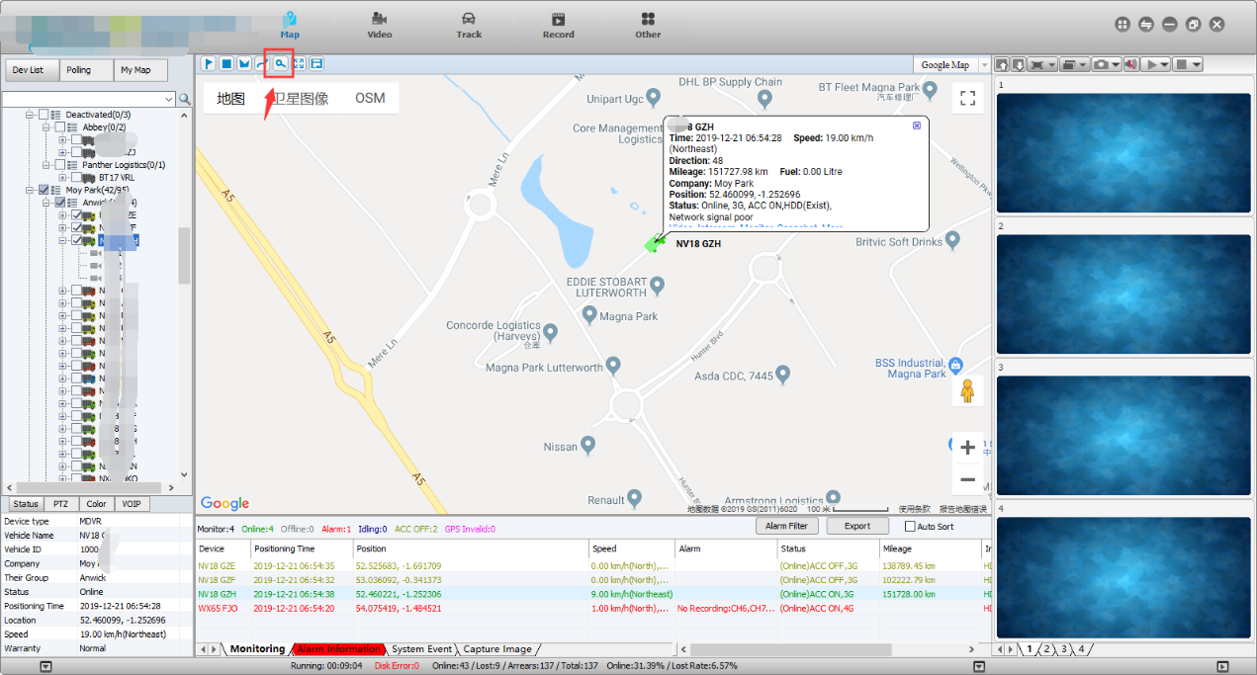

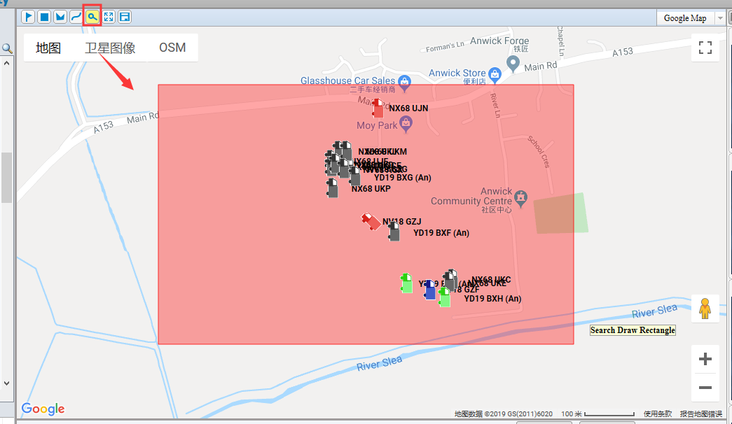

2. It will pop-up the area serach page, then you can choose the time and device to search which time these device at this place.

