How to use command delete the user_log data

​When we upgrade IVMS Server, if the user_log table have so many data, it will will slow, so we need to clear the user log first.

1. Use Navicat for MySQL software connect to mysql, then find the user_log table, you can download the software from this link.
https://www.dropbox.com/sh/a44t2tv3o78jok4/AAA6vG9AeX1yeDamAwcfMiSka?dl=0

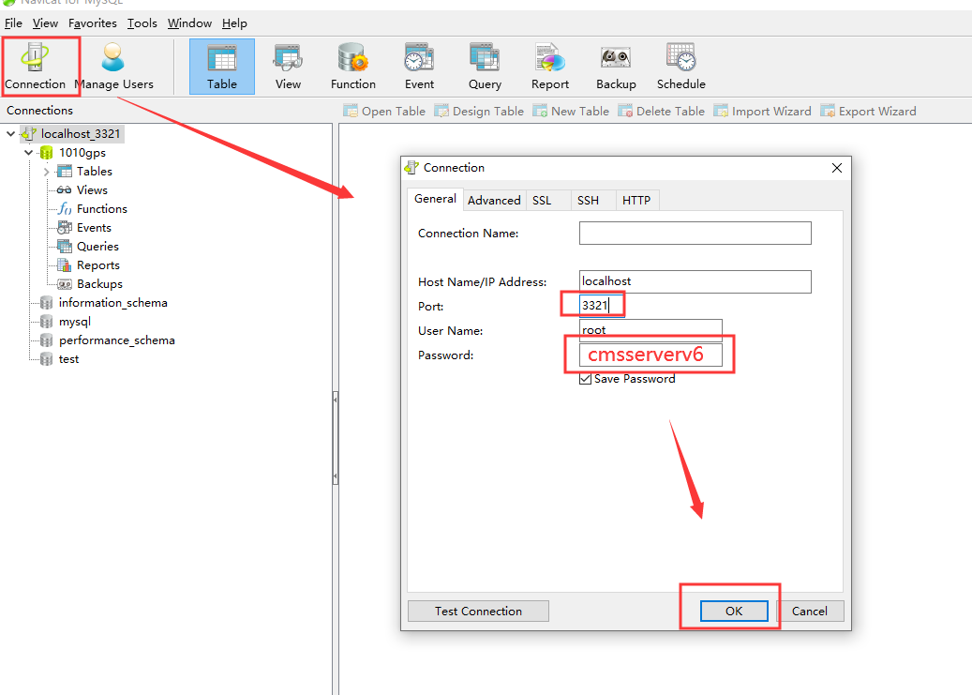

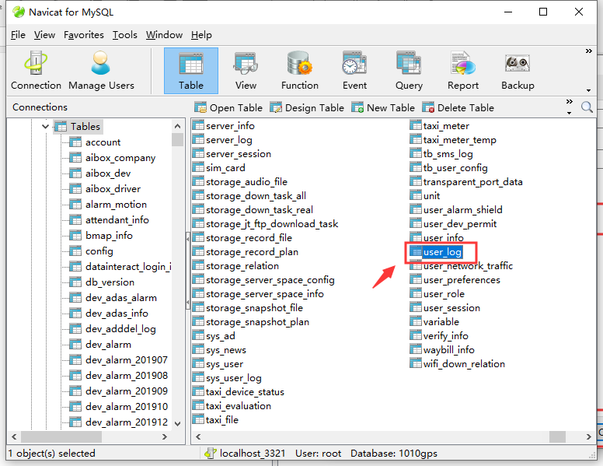
2. Check the table information to know how many data does it have.

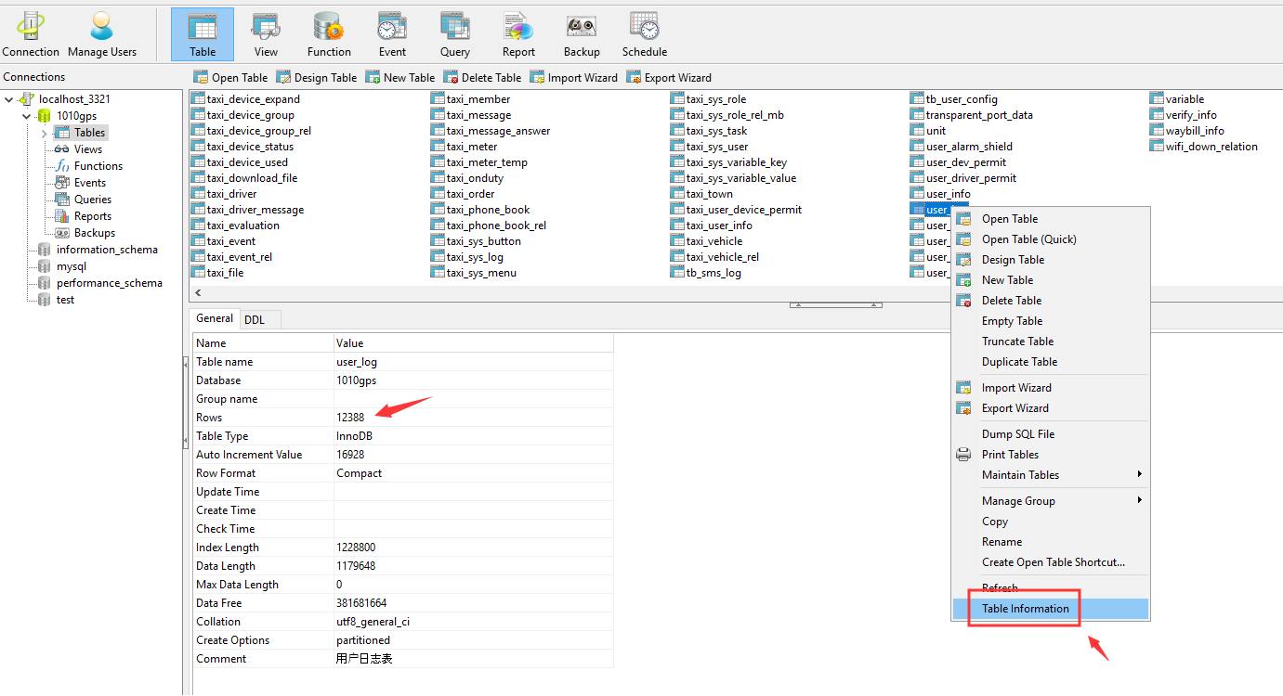

3. If the data is very huge, you can use command delete it, it maybe need some time to delete the data, when it finished, it will show like .
Command: truncate table user_log

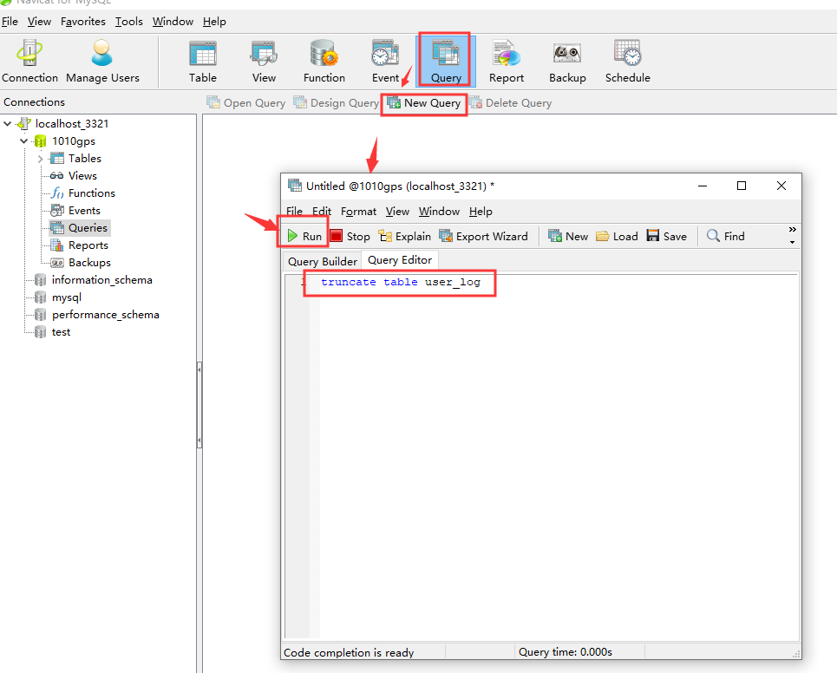

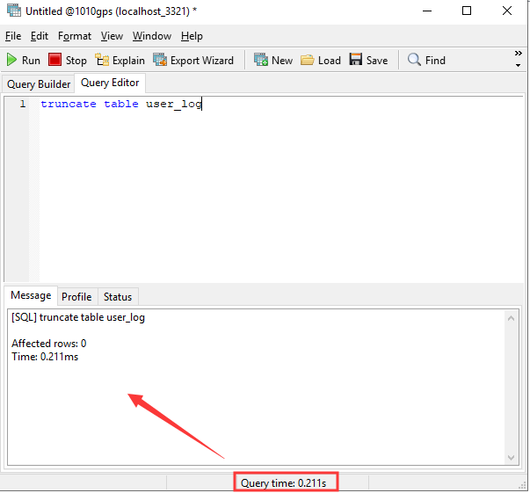

4. Open the user_log table again, you will see it had cleared.

