Why does Panice Button not appear in the Alarm Information list

Question:

Someone connected the emergency button to IO_1 and named it Emergency button.
It appears in the interface but does not appear in the Alarm Information list.
Also he changed the IO_1 type from Event to Alarm and the "Image upload alert" appears.

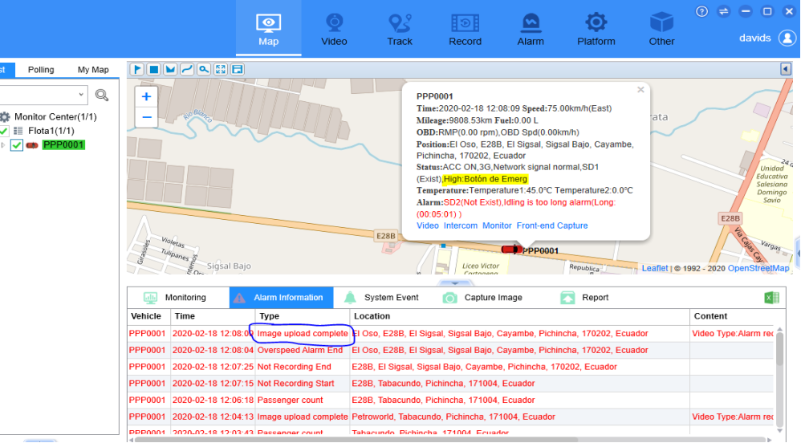

Answer:

From the picture you sent, the "image upload complete" was between the "Passenger count".
So I think the Passenger counter and emergency button was conflicting.
In fact the IO1 is the default Emergency button. But we can also define the IO3 as Emergency button when you edit the Device info with admin account.



