How to know the path of GPS data and snapshot of IO input

​Plesase:
Click the "Open file location"> Open the GPSDataSvr
Then you can see the path of GPS data storaged as below.

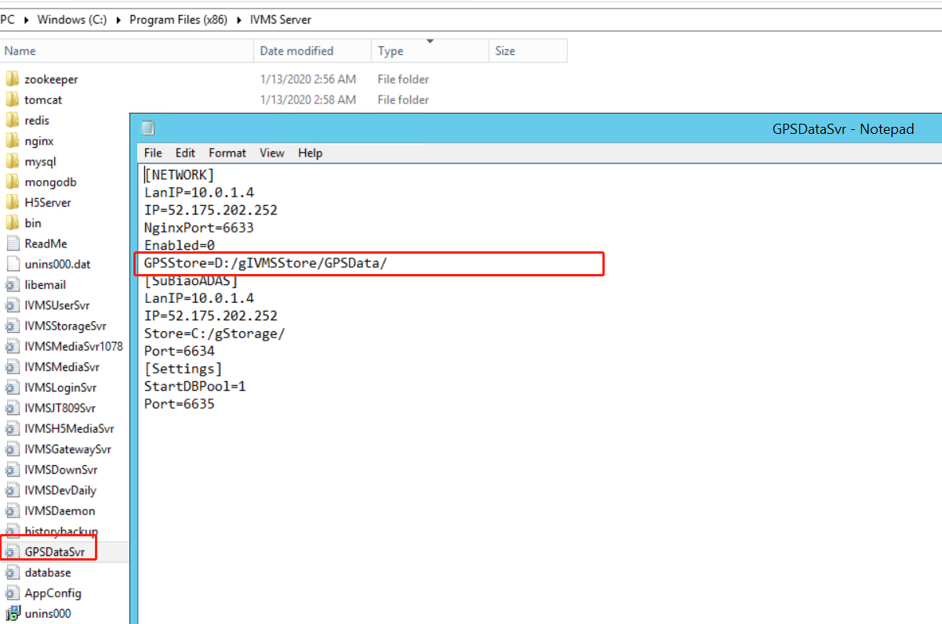

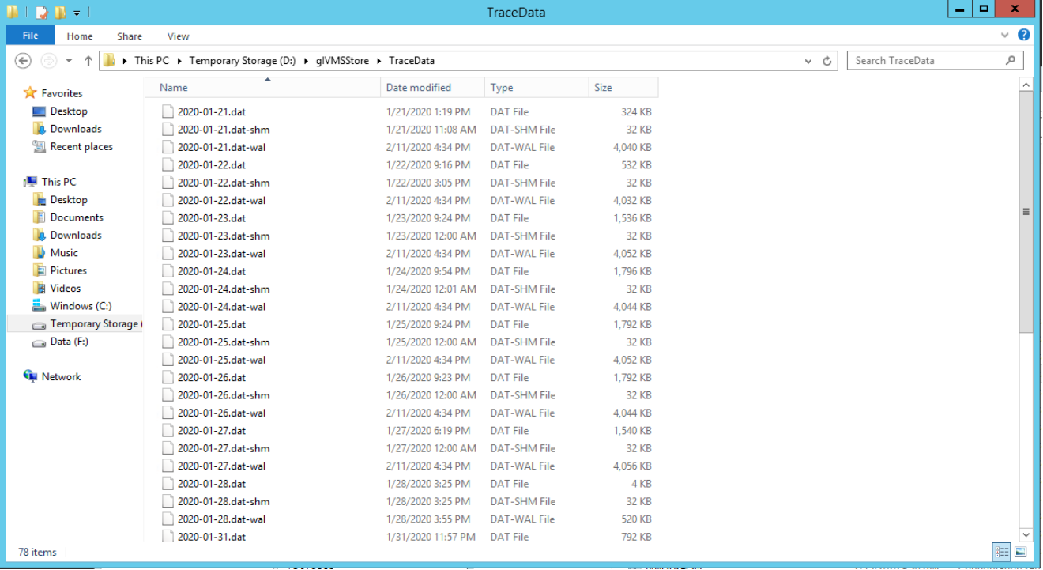

Path of IO input snapshot usually storage in Gstorage as below.

