How to check the system info status

​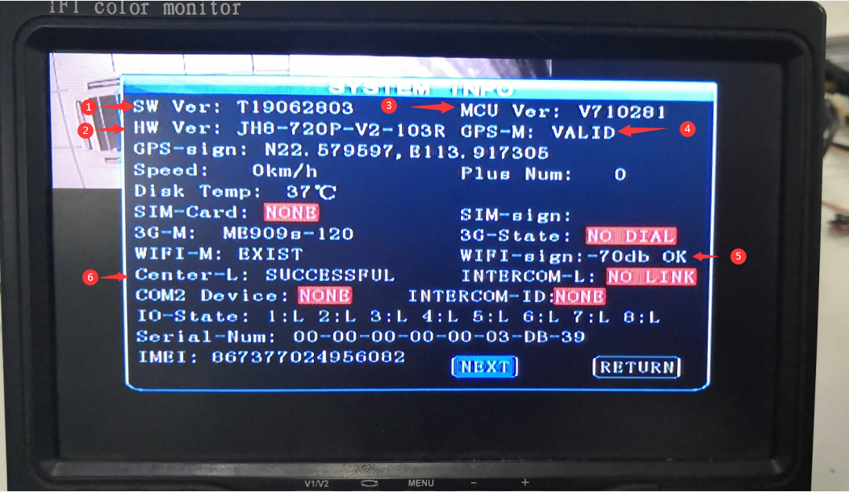

- SW Ver means sottware version, also named firmware version.
- HW Ver means hardware version
- MCU Ver means Microcontroller Unit
- GPS Valid means GPS connected successful
- WIFI sign -70db OK means wifi settings is right, and connection successful
- Center-L successful means MDVR can connect to IVMS Server successful

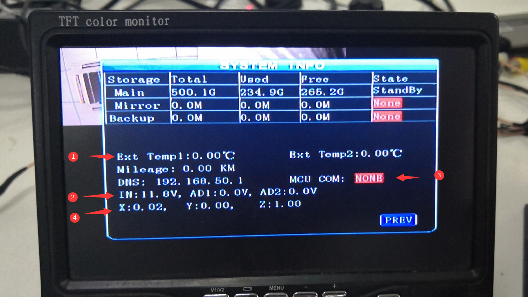

- Ext Temp means external temperature sensor
- This means the real voltage input
- MCU COM mean RS485 serial device connection
- X,Y,Z means G-sensor x,y,z value

