How to remove the Session ID for customer to integrated the API

​1. First, stop the media server and open the IVMS Server installation directorym and find this file.

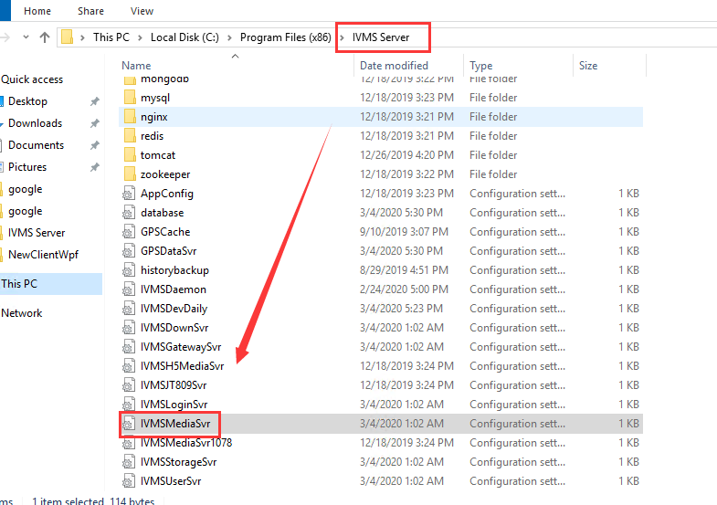

2. Then add this to this fille, and save it.
[HTTPService]
HttpLoginRequired=0

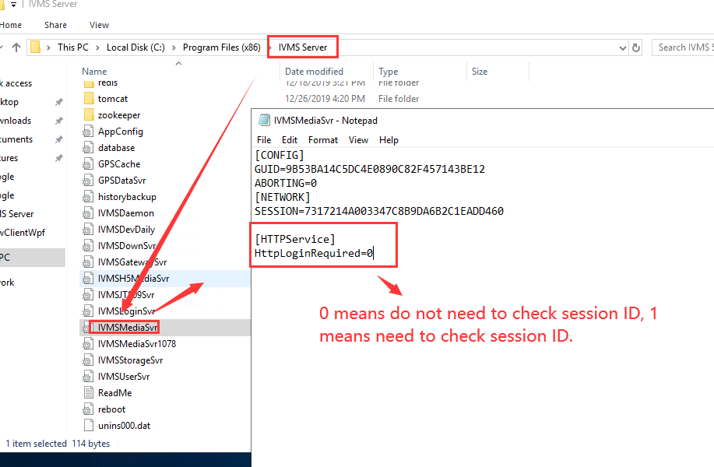

3. Restart the media server, then you can use it check the api now, you will find it can preview video or do other without session ID.

