How to IVMS Client show "server find the file error"

​When we want to change the parameters or upgrade the firmware, it will show "server find the file error", then we can not change parameters or upgrade the firmware any more. The reason why it can not change is that there are too many Configuration files and upgrade files inside the server, and the server do not have enough space to storage it.

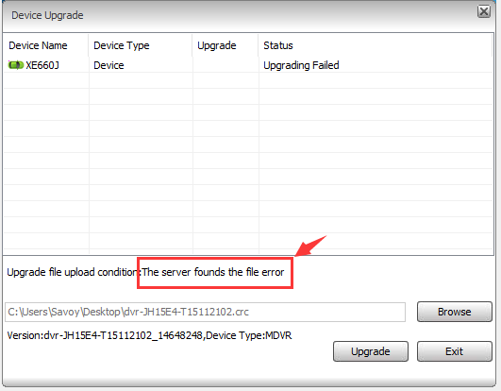

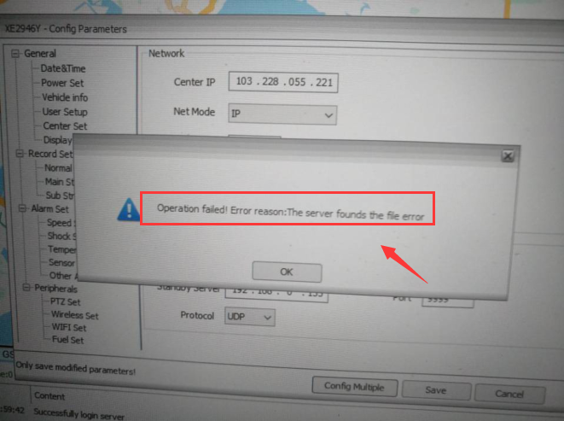

1. Open the IVMS Server installation directory, find this folder and check if the disk have space or not, delete all the file at this folder, and keep the disk space is enough for server running.

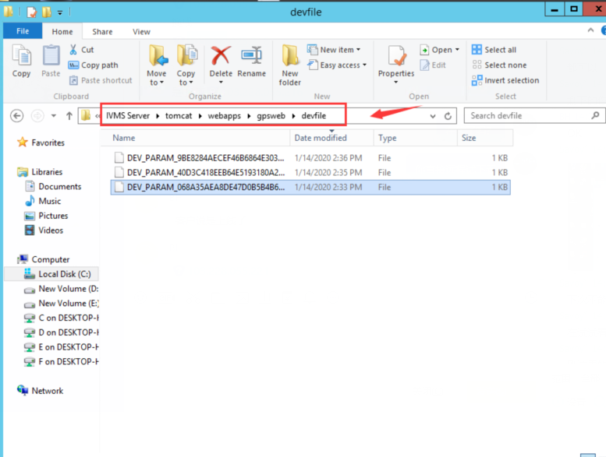

2. Restart the server, then try to change the parameters or upgrade the firmware at IVMS Client again, you will see it is woking.

