How to enable the options for Geo-Fence, Route, Point of Interest

​Q:
In the IVMSClient-WPF on the maps you have the option to create points of interest, geo-fence, routes, but why there is no these option in IVMSClient with the same account.

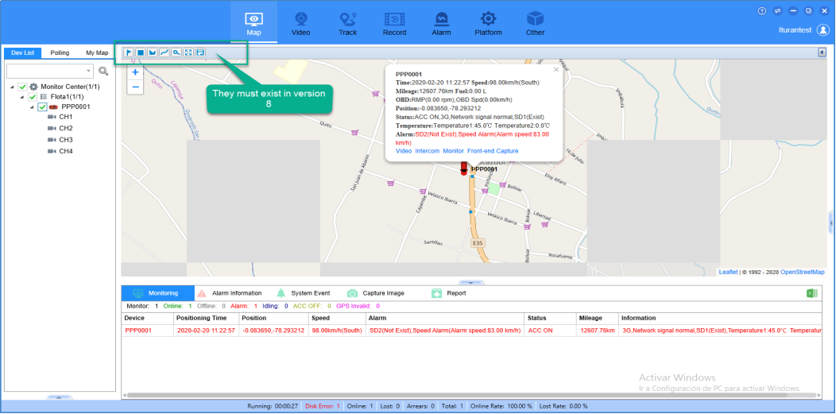

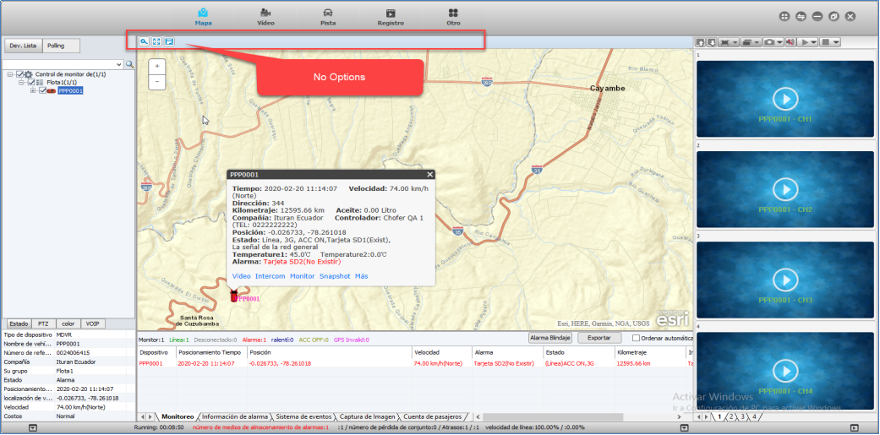

A:
The IVMSClient-WPF(V7) does not make permission control.
The IVMSClient(V8) will control the UI display according to the permissions of the role, Which your account belonged to.
Here is the method of how to enable the options for Geo-Fence, Route, Point of Interest.
You can click the "Role Management" and edit the roles your account belong to. Then click the the options you need as below.

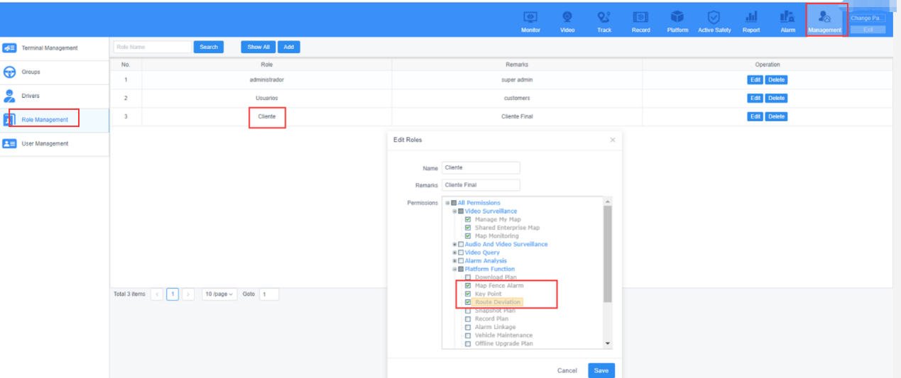

You will get the options for Geo-Fence, Route, Point of Interest after you enable them.

