Answer to the Questions of SD card storage

​Q1 - When two SD cards are installed, the video and logs are recorded at the same time in both SDs? Or is there other logic (for example the SD1 is recorded all the time and only after, say 10 minutes, the content is backed up in the SD2).
A1 - The logic is: The one will record when the other one is full or recording failed .

Q2 - Is possible to use the SD2 to increase the storage capacity or is always used as backup.
A2 - SD2 is not for backup but stand by for the SD1 failed.

Q3 - I see that not the total capacity of the SD is used, for example I'm using a 64GB but only 51 GB are used for the video and around 9GB remains always free.
A3 - As you known, the write Speed of SD/SSD is very slow when the SD/SSD near full. The firmware code define that it remains 7% free.

Q4 - When I generate an alarm event that requires explicit recording, where these files are stored? are they in an special folder or are mixed with the other files?
A4 - It is stored in the same folder with the normal files.

Q5 - Please provide more information on the logic to record the videos in the SD cards when there are two installed. The 2nd SD is the backup of the 1st SD (this mean that the video is stored at the same time on both SDs)? or when the 1st is full the 2nd starts to record (serial recording)?
A5 - The SD card MDVR will use second methods as you mentioned above.
It starts from 1st and will record on the 2nd when 1st is full, in case of one card has malfunction, the system will automatically record on good card.

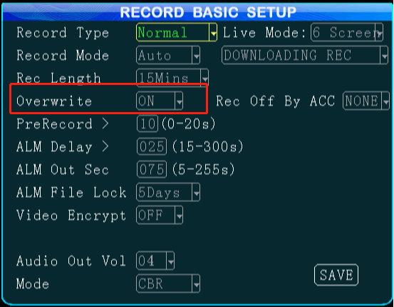

Another logic related is for the Overwrite, the system will delete the oldest footage file in SD card when the user turned on the “Overwrite” function in MDVR.
Two scenarios,
when the total capacities of SD card(s) are larger than 120GB,
the system will delete chosen SD card when it has only 5% left, and delete footage files =1%, it will repeat this action until the footage files on 2nd SD card are oldest.
for the capacities of SD card(s) are smaller than 120GB,
the system will delete chosen SD card when 8% left and will delete footage files=16%.
One important thing about Overwrite is the system can not delete footage marked as Alarm video.

