How to assign different permissions to different accounts

​1. Log in the admin account, and set up the first level account. I use adminuser as the first level account, like manager.

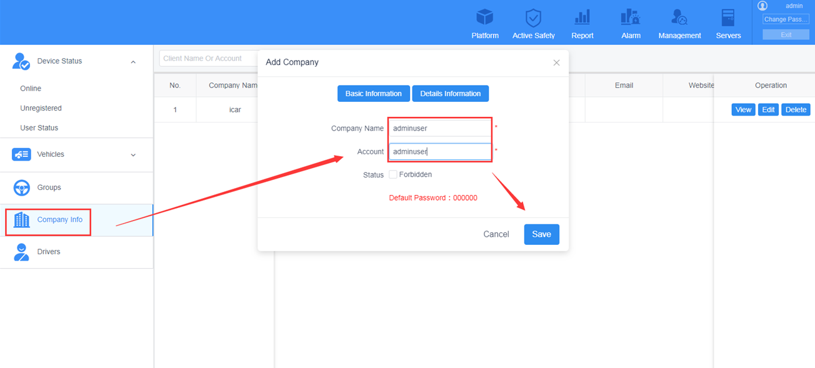

2. Log in the first level account, the roles need be assigned under the first level user account, not admin.

3. After log in the adminuser account, add the different roles like the following, give the different permissions to different users.

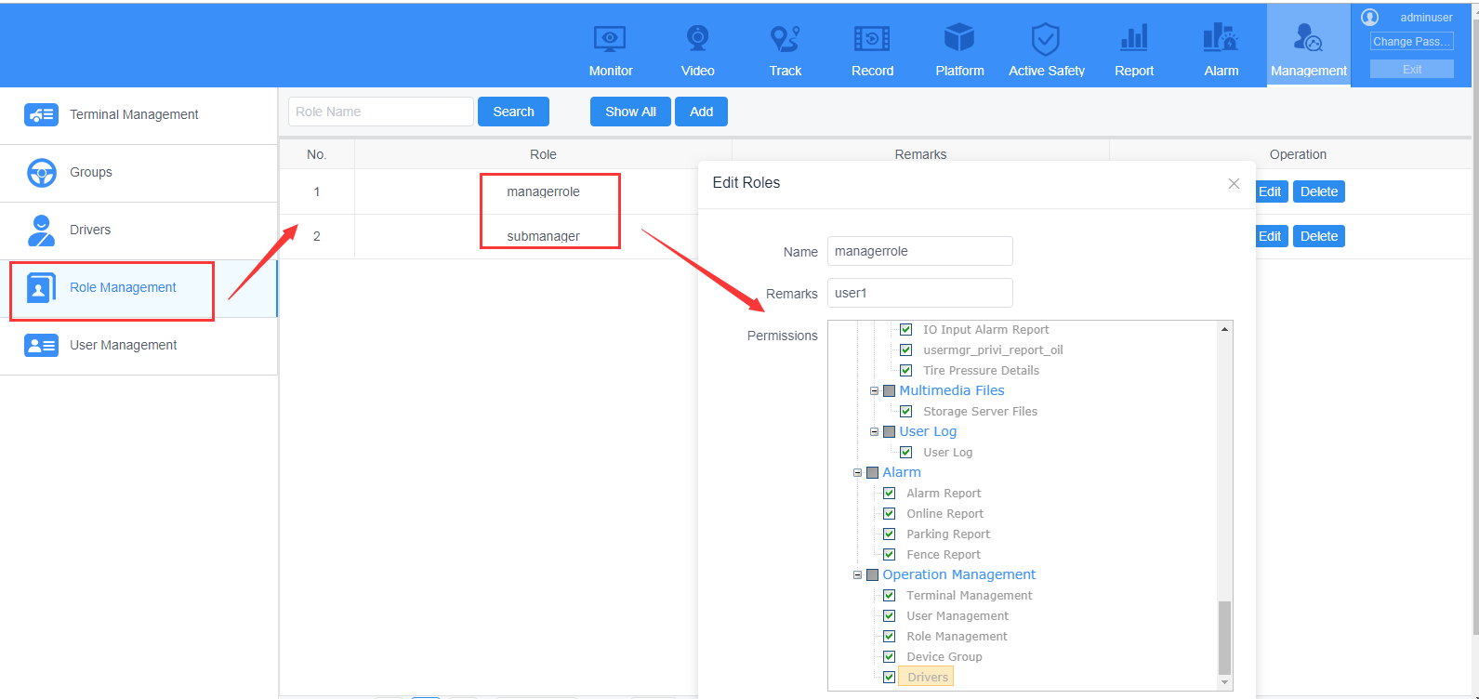

4. And then go to the user management, add two different users, here, name them with user1 and user2, user1 ihas the manager role, and user2 has submanagmer role. Then give them different roles according to the roles we add before.

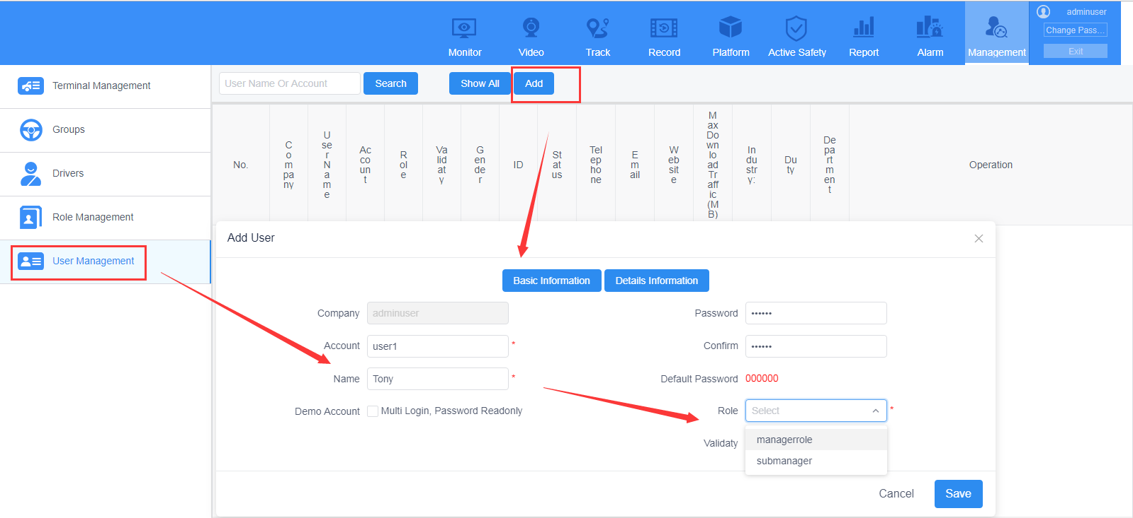

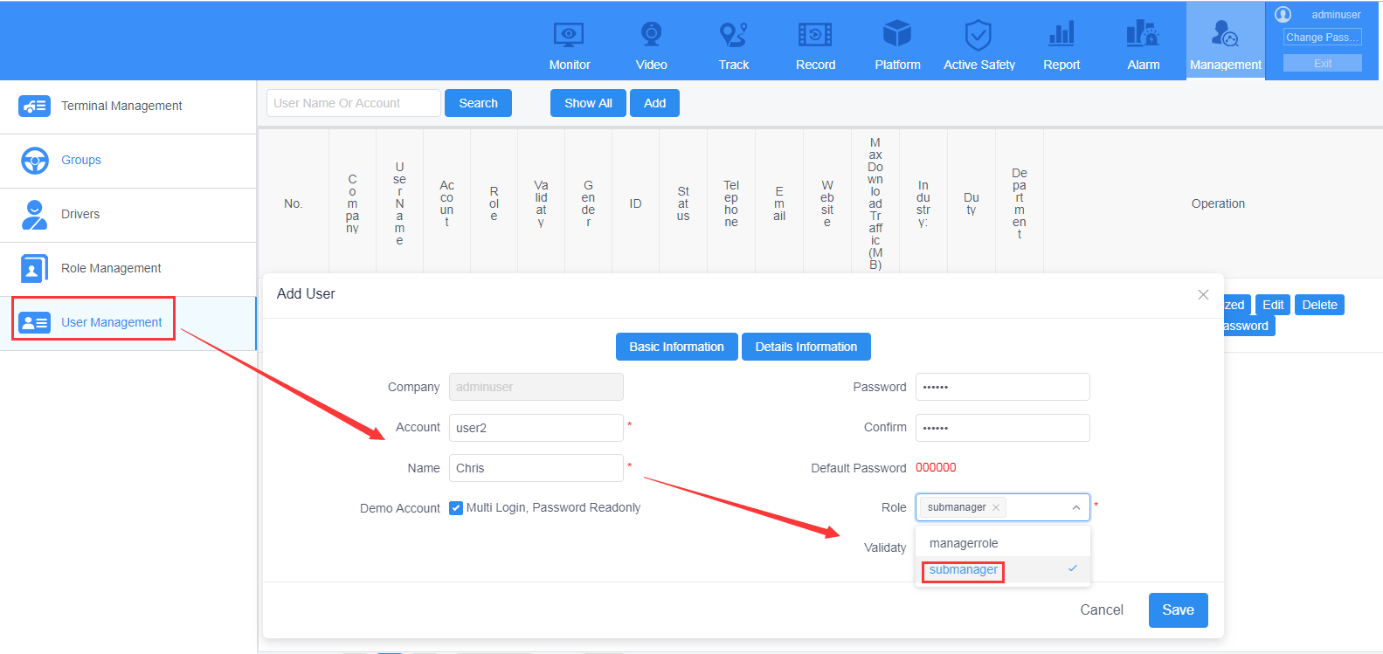

5. Then you can login the user1 and user2 to check the different roles that assigned.

