System-info of MDVR is Online

but Offline with IVMSClient
There is a strange phenomenon that System-info of MDVR is online but offline with IVMSClient.
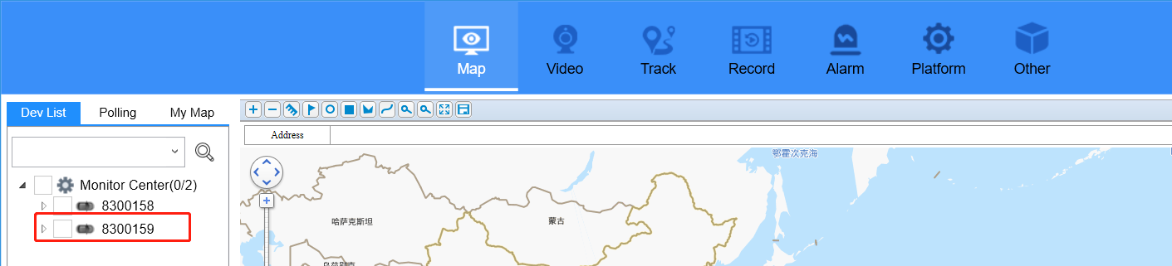
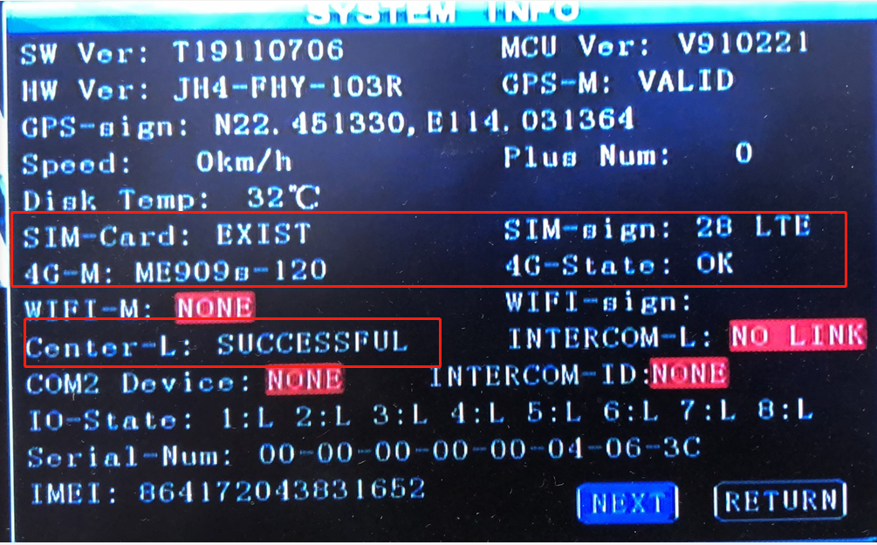

Please unchecked the option about “Use SIM as Dev-ID”.
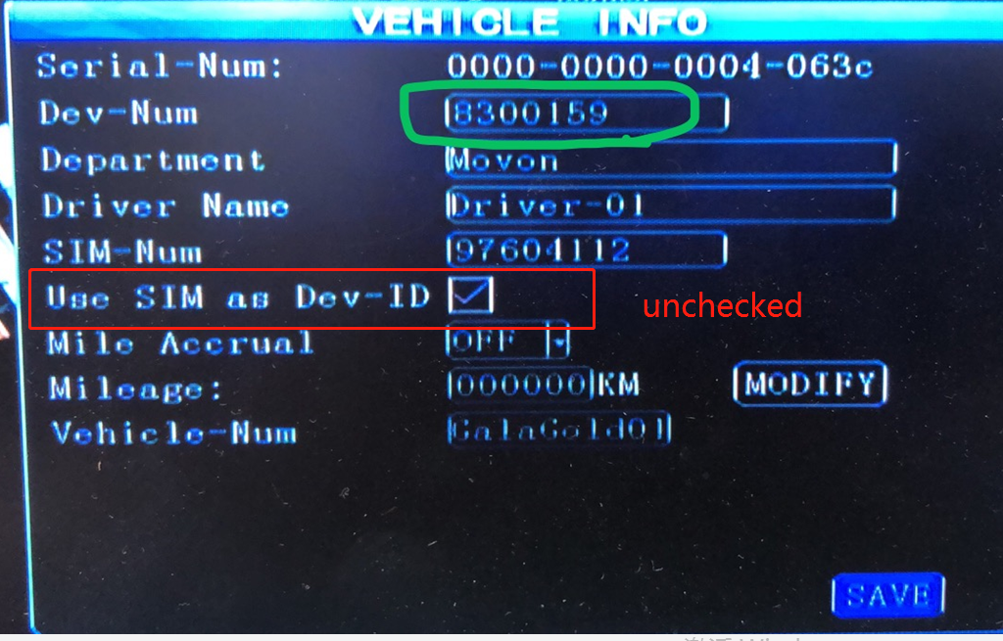
After that, you can see your vehicle online with IVMSClient.

