How to restore the basic data of mysql

1. First, install the server again, and choose the old server's database backup path, then use it to create a new mysql.
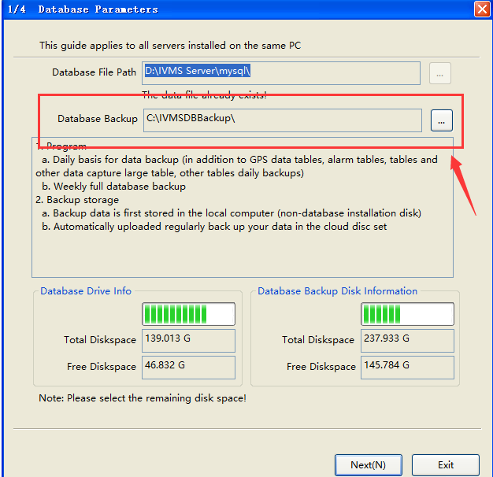
2. Click the Database button, then choose Advance option, you will see some different function at this page.
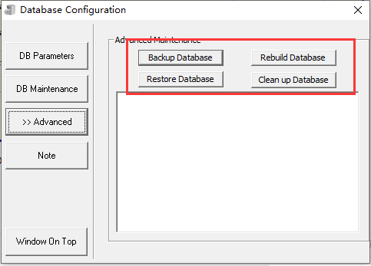
3. Click the Restore Database button, restored process will first check previous backup data in REPAIR folder, if can't find REPAIR folder, there will find parent directory IVMSDBBackup folder to restore, you can choose restore the basic data or big data (it take long time to restore the big data), also can choose the restored days.
Notice: Please check the last backup time, if the time is not same as your server PC time, please change your PC time to the last backup time day, or it will can not restore the basic data.
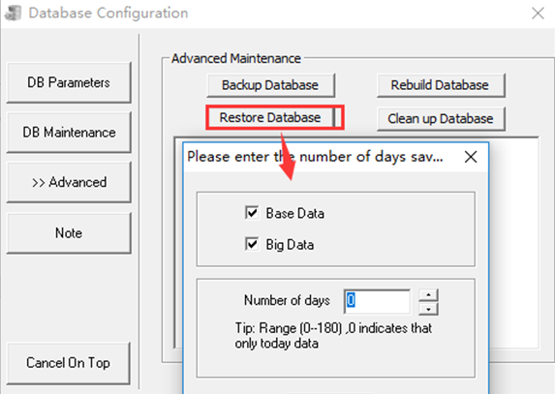
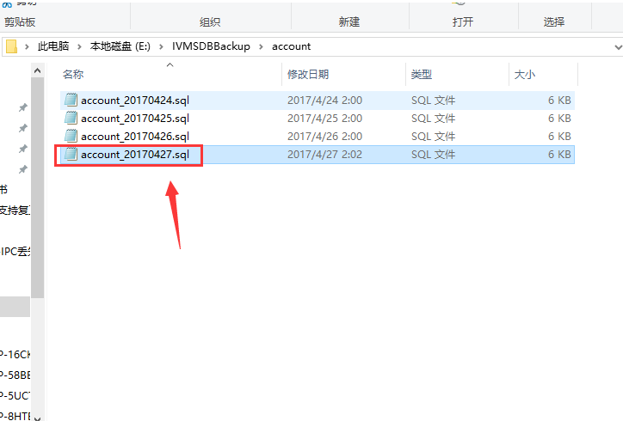
4. When it finished, it will ask you to stop all the IVMS service and run the DBcheck.exe to update the database.
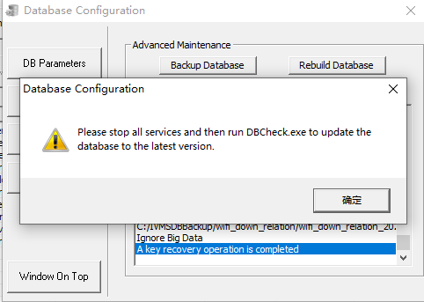
5. After stop all the service, click start to run DBCheck.exe, then it will backup the basic data to the new mysql side, stop all the IVMS service, then change your server PC time back and run the IVMS Server again.
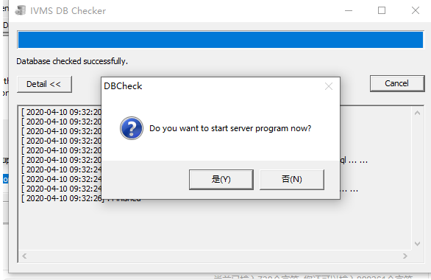
6. When IVMS Server is running, then you can login the web to check the device and account.

