How to fix the Passenger-Counting Camera display splash screen problem
1. First, check the MDVR's display is right or not, change the RCA and TVOUT try again.
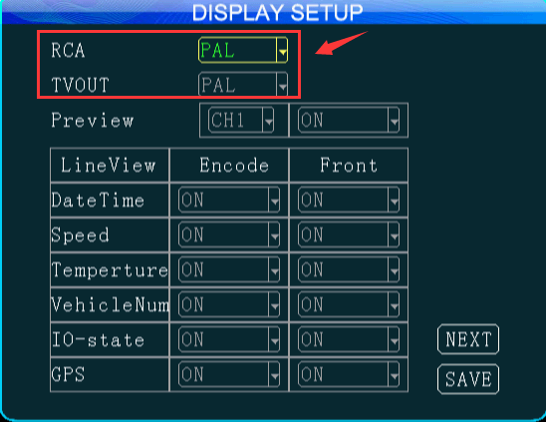
2. If it still have problem, check with the Passenger-Counting Camera factory, then try to upgrade the firmware like this, it will restart itself.
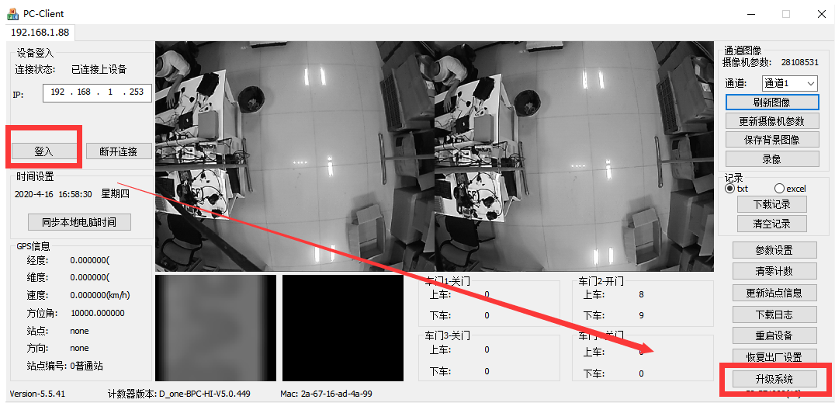

3. Remove the Passenger-Counting Camera's screw, then find the red cable, remove it, and put it back.
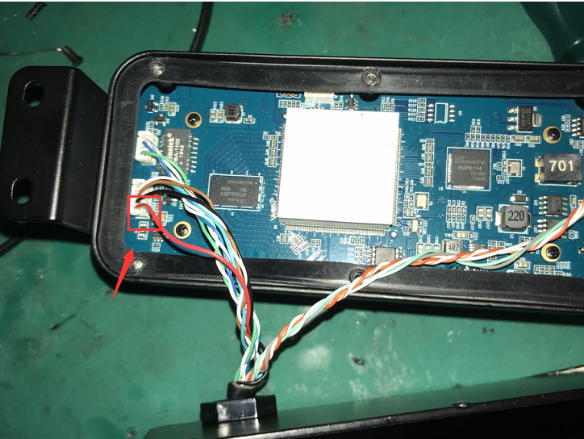
4. Power on the Passenger-Counting Camera and connect it to MDVR again, you will see it is working good now.

