Check the validity of Google map API KEY when use MDVR Player
There is the FAQ about how to add Google map API KEY to the MDVRPlayer.

https://www.icarvisions.com/faq/google-map-of-mdvrplayer-408.html

After that,there is a srtange phenomenon that you have added your Google map API KEY but google map still failed as below.
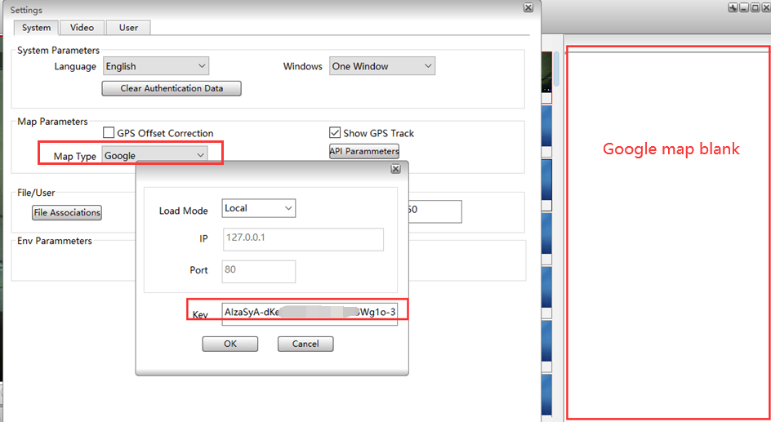
Please follow the steps to check if your Key worked with the MDVRPlayer.
- Click the “ libmap ” file from the Path.
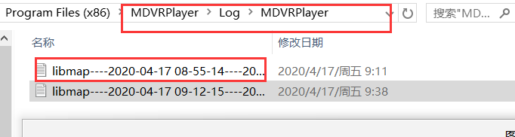
- Copy the “ GetMapPtah ” to your Google Chrome.
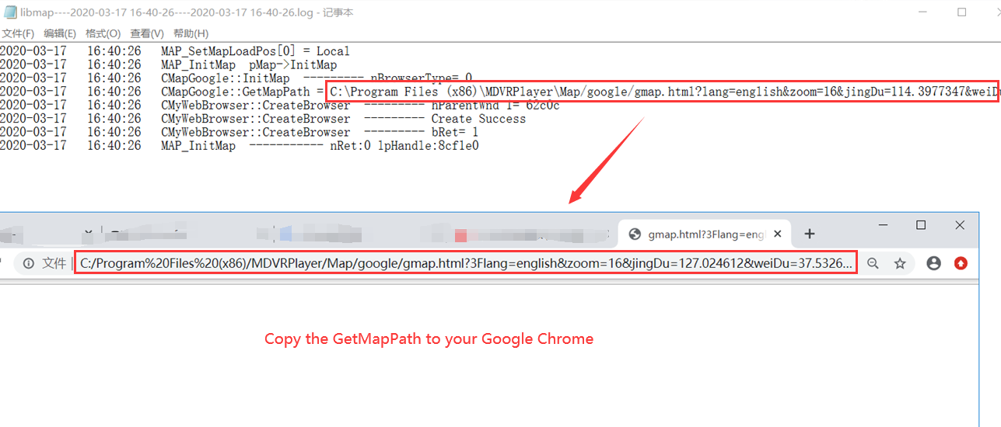
- Make sure the code is “ ? ” not “ % “.
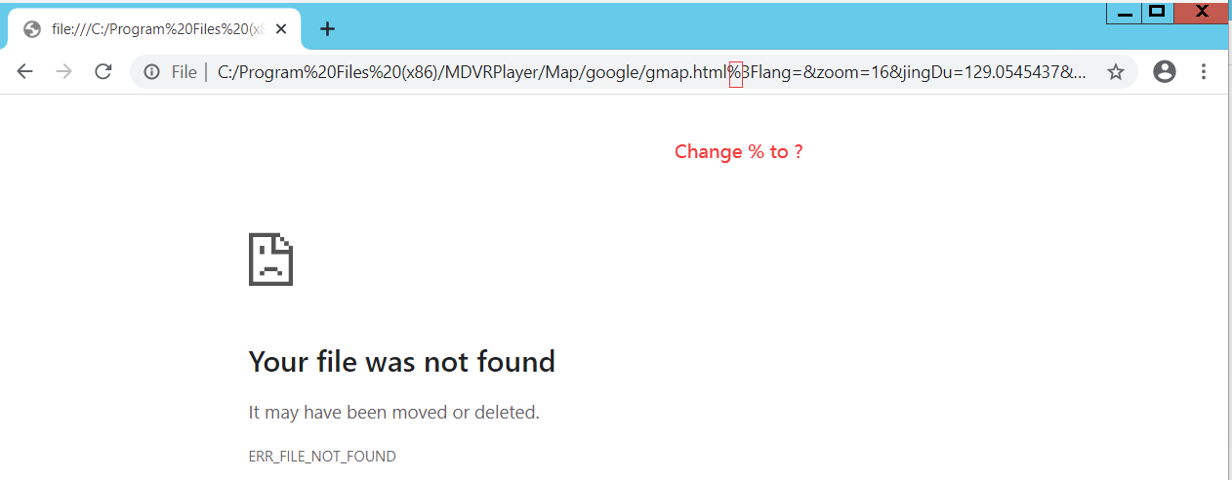
- The Google Chrome could show the google map successfully if your Key was effective.
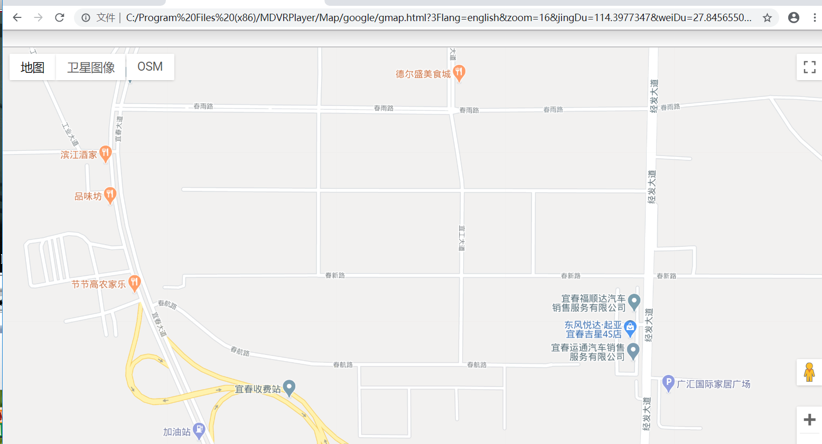

- The Google Chrome could not show the google map successfully if your Key was Invalid.
